**Can courts in non-democracies deter election fraud? De jure judicial independence, political competition, and election integrity**

ONLINE APPENDIX

Cole J. Harvey

Contents

Balance statistics for entropy weighting 2

Interaction effect validation 2

Using pro-government intimidation and vote-buying as alternative measures of manipulation 4

Alternative pre-processing method 6

Balance improvement for CBPS method 9

Results of the selection model 11

Comparative constitutions project data 12

Inter-temporal effects of reform within cases 16

Judicial independence and the risk of post-election protest 23

Regression table for electoral court models 28

Alternative coding of democracy 29

The post-Cold War effect 32

Lagged election manipulation as a selection variable 34

Government control of the legislature as a selection variable 37

Judicial independence and access to the courts 39

Bibliography 43

## Balance statistics for entropy weighting

Table A.1 reports the variables used in the pre-processing phase for Model 2, as well as the means for the treatment group, the control group after entropy balancing and weighting, and the unweighted control group. There are sizable improvements in balance associated with *opposition autonomy*, *Polity score*, *high-* and *low-court independence*, *transitional election*, *duration of the regime*, and *executive respect for the constitution*. All of these are theoretically important variables for predicting attacks on the judiciary, suggesting that the re-weighted data will improve estimation of the causal effect of judicial independence compared to the raw data.

|  |  |  |  |
| --- | --- | --- | --- |
|  | | | |
|  | Treatment group means | Weighted control group means | Unweighted control group means |
|  | | | |
| Duration of the current constitutional regime | 27.031 | 27.032 | 34.821 |
| Opposition autonomy | 1.164 | 1.164 | 0.608 |
| Opposition oversight | 0.744 | 0.744 | 0.019 |
| Latent judicial independence | 0.412 | 0.412 | 0.382 |
| GDP per capita (log) | 7.559 | 7.559 | 7.926 |
| Urbanization | 0.446 | 0.446 | 0.477 |
| High-court independence | 0.421 | 0.421 | -0.274 |
| Low-court independence | 0.673 | 0.673 | -0.119 |
| Transitional election | 0.016 | 0.016 | 0.057 |
| Executive respect for the constitution | 0.957 | 0.957 | 0.283 |
| Alternative information index | 0.722 | 0.722 | 0.545 |
| Education | 4.395 | 4.395 | 5.510 |
| Legislative constraints on the executive | 0.590 | 0.590 | 0.433 |
|  | | | |

Table A.1: Balance improvements for covariates used in entropy balancing (Model 2)

## Interaction effect validation

Linear multiplicative interaction models of the kind used here can be misleading if the assumption of a linear change in the marginal effect does not hold and/or there is a lack of common support—meaning that either the treatment or control condition is available over only a limited range of the moderator. To help validate interaction results, Hainmueller et al (2019) propose dividing a continuous moderator into discrete bins, and then estimating the marginal effect of the treatment on the dependent variable for the median value of each of those bins. This has the advantage of enabling the researcher to visually inspect the assumption of linear trends (by comparing the positions of the resulting marginal effects), and of testing the marginal effects only for typical values of the moderating variable. Diagnostic plots using this test are presented in Figure A.1. The standard marginal effect plot is overlaid by the point estimates and 95% confidence intervals of the binning method. The plots show that the general marginal effect is not driven by extreme values of the moderator, suggesting that common support is upheld. In three of the four models, the first and second tercile marginal effects are statistically significant; in Model 1 only the first tercile estimate is. They also show that the assumption of linear interactive effects is well supported, with the possible exception of Model 1 in the upper left quadrant where the point estimate falls just outside the 95% confidence interval for the linear model. Though the confidence interval of the point estimate itself overlaps with the general model, it is still worth investigating Model 1 more closely.

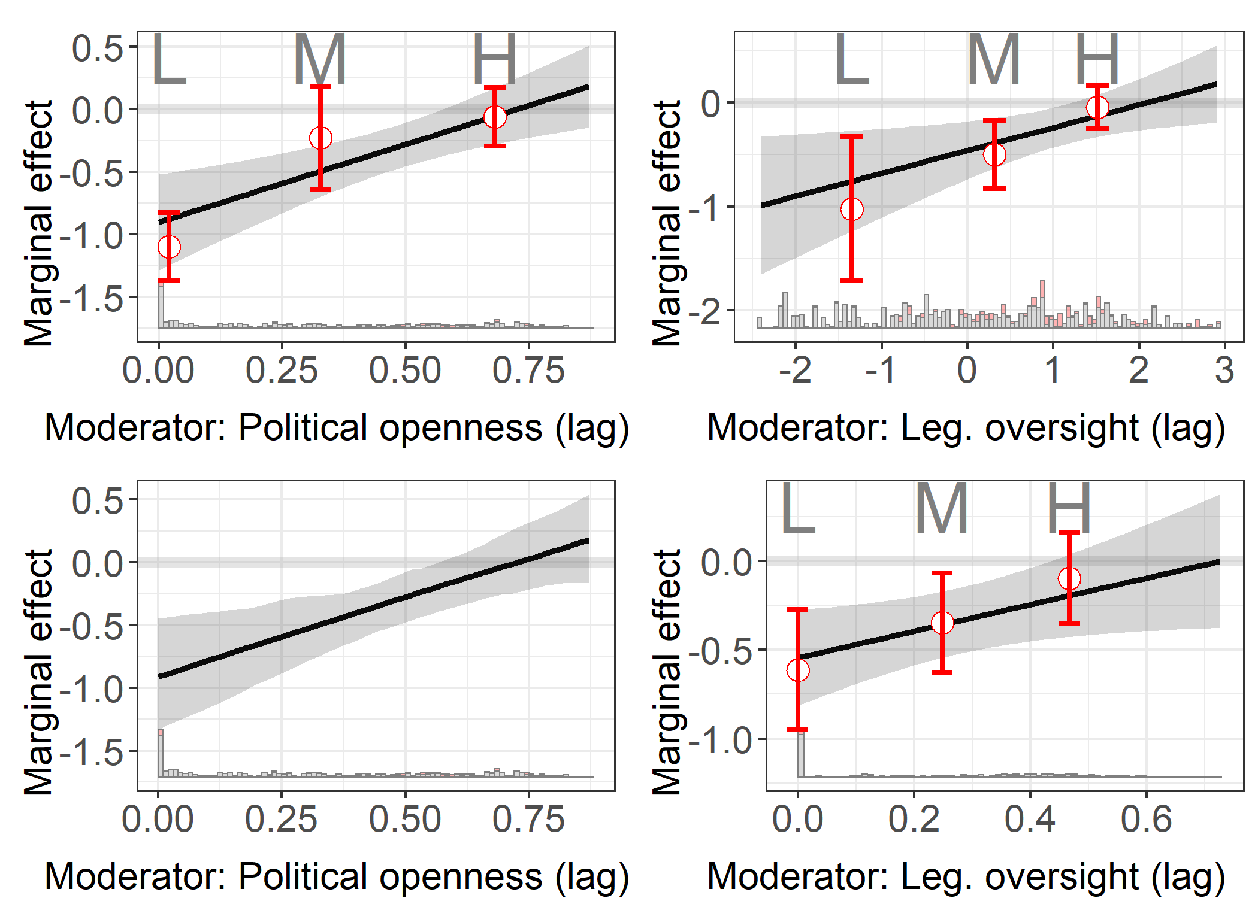

Figure A.1: Validation plots for linear interaction models

To further test the linear interaction effect assumption, Hainmueller et al (2019) propose a kernel smoothing estimator of the marginal effect. By estimating the marginal effect of the treatment at a series of small ranges of the moderator, the overall marginal effect is not confined to a linear trend; in other words, this method is able to detect non-linearities at a fairly fine-grained level of detail. Figure A.1 presents the results of this diagnostic in the lower left, and shows negligible evidence of nonlinearity. The results of these diagnostics show that the assumptions underlying the linear interactive model are well supported.

## Using pro-government intimidation and vote-buying as alternative measures of manipulation

The main analysis utilizes electoral fraud as a dependent variable, but other forms of illegal electoral manipulation can also be addressed by courts; incidents of electoral violence and intimidation or vote-buying may both find their way to the courts. The variable *pro-government intimidation* is taken from V-Dem, and captures the extent to which the opposition was subject to “repression, intimidation, violence, or harassment by the government, the ruling party, or their agents” (Coppedge, Michael et al., 2017). *Vote-buying* is a measure of the degree to which parties relied on the distribution of money or gifts to turn out and/or persuade voters (Coppedge, Michael et al., 2017). As with *intentional voting irregularities* in the main text, both variables have been multiplied by -1 so that higher values indicate more severe manipulation. As Table A.2 and Figure A.2 show, a positive judicial reform has the same effect on intimidation and vote-buying in interaction with legislative opposition oversight as it does on fraud.

|  |  |  |
| --- | --- | --- |
|  | | |
|  | *Dependent variable:* | |
|  |  | |
|  | Intimidation | Vote-buying |
|  | (3) | (4) |
|  | | |
| Judicial reform | -0.357*** | -0.274*** |
|  | (0.081) | (0.074) |
|  |  |  |
| Opposition oversight | -0.337*** | -0.196*** |
|  | (0.034) | (0.031) |
|  |  |  |
| Executive election | -0.079 | -0.071 |
|  | (0.067) | (0.061) |
|  |  |  |
| Proportional representation | 0.045 | 0.068 |
|  | (0.082) | (0.074) |
|  |  |  |
| Mixed electoral system | -0.172* | -0.073 |
|  | (0.093) | (0.085) |
|  |  |  |
| International observers | -0.144*** | -0.112** |
|  | (0.050) | (0.045) |
|  |  |  |
| Negative judicial reform | 0.088 | -0.082 |
|  | (0.102) | (0.092) |
|  |  |  |
| GDP per capita (log) | -0.081 | 0.026 |
|  | (0.067) | (0.061) |
|  |  |  |
| Judicial purge | -0.116** | -0.003 |
|  | (0.050) | (0.045) |
|  |  |  |
| Court packing | -0.395*** | -0.178*** |
|  | (0.065) | (0.059) |
|  |  |  |
| Positive judicial reform : Opposition oversight | 0.163*** | 0.047 |
|  | (0.052) | (0.047) |
|  |  |  |
| Country fixed effects | Yes | Yes |
| Constant | 2.298*** | 1.379*** |
|  | (0.559) | (0.506) |
|  |  |  |
|  | | |
| Observations | 727 | 727 |
| R2 | 0.891 | 0.875 |
| Adjusted R2 | 0.870 | 0.850 |
| Residual Std. Error (df = 605) | 0.236 | 0.214 |
| F Statistic (df = 121; 605) | 41.023*** | 34.905*** |
|  | | |
| *Note:* | *p<0.1; **p<0.05; ***p<0.01 | |

Table A.2: OLS models of alternative measures of election manipulation. All non-electoral variables lagged one year.

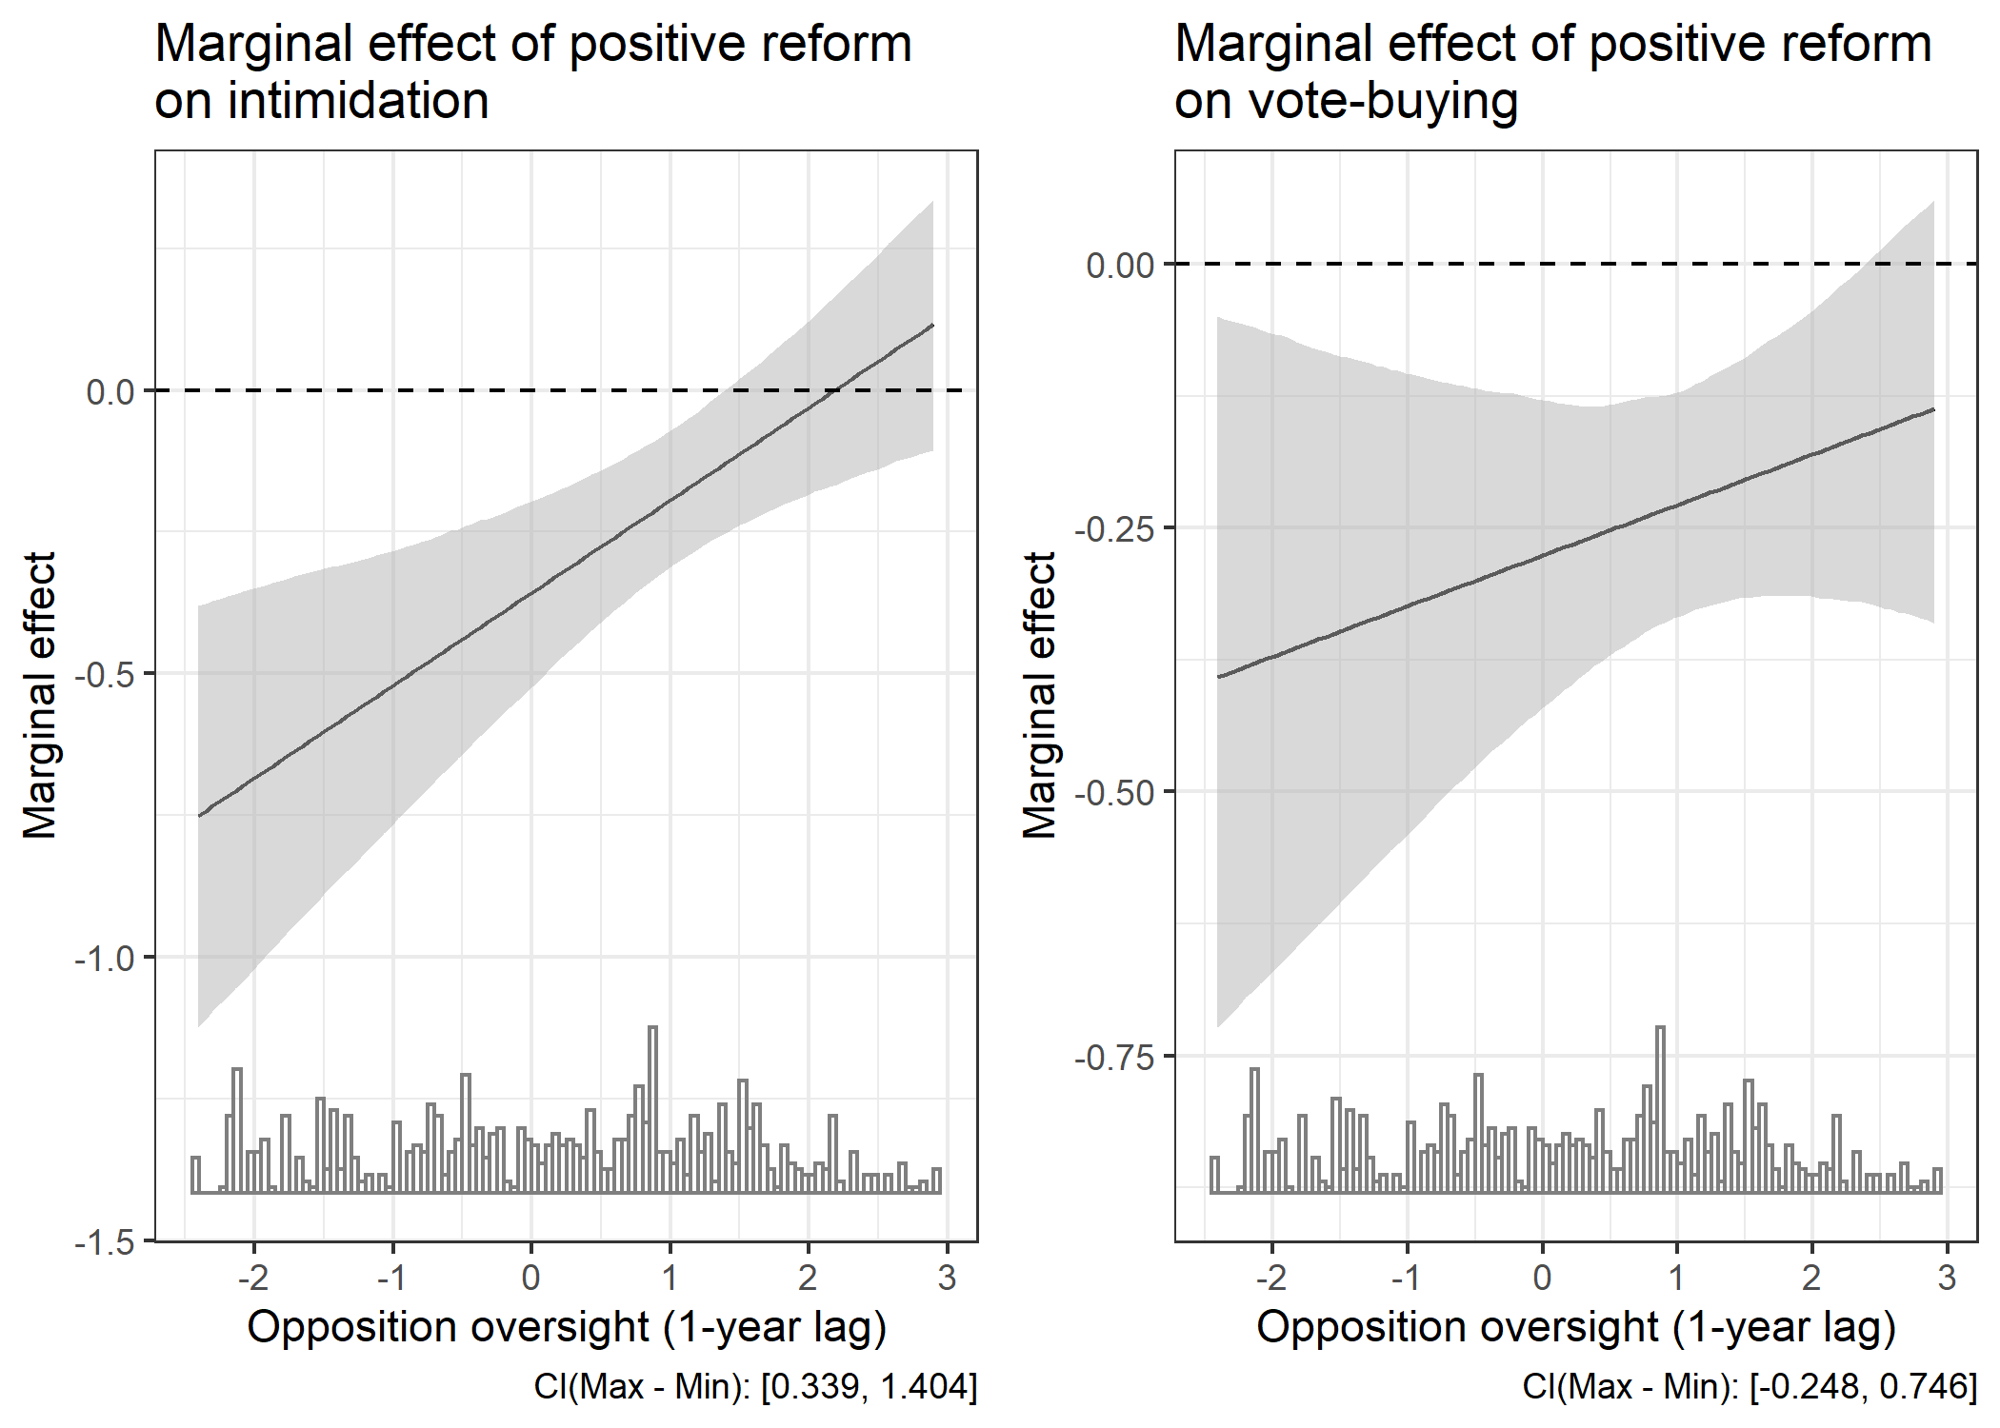

Figure A.2: Marginal effect of positive judicial reform on alternative measures of election manipulation. Shaded areas represent 95% confidence intervals adjusted for marginal effects.

## Alternative pre-processing method

To demonstrate that the results are not driven by the specifics of the entropy balancing procedure, I also employ covariate balancing propensity score (CBPS) weighting as an alternative approach (Imai and Ratkovic 2014). Rather than directly estimating control weights that balance the means of covariates as in entropy balancing, the CBPS method of pre-processing estimates the propensity scores (i.e. the probability of being in the treatment group) such that weighting observations by propensity score results in covariate balance across treatment and control groups. While similar to entropy balancing, one distinguishing feature of this approach is that control observations with high propensity scores (and treatment observations with low propensity scores) take on greater weight in the subsequent regression models. This is useful since observations that more closely resemble the counterfactual are given greater weight in the subsequent models. The same variables were included in the pre-processing and analysis phases as in Models 2 and 4 in the main text. Table A.3 and Figure A.3 show that the results of models using CBPS weighting are equivalent to those using entropy balancing.

|  |  |  |  |
| --- | --- | --- | --- |
|  | | | |
|  | *Dependent variable:* | | |
|  |  | | |
|  | Intentional voting irregularities | | |
|  | (5) | (6) | (7) |
|  | | | |
| Positive judicial reform | -0.759*** | -0.419*** | -0.494*** |
|  | (0.110) | (0.082) | (0.090) |
|  |  |  |  |
| Political openness | -0.835*** |  |  |
|  | (0.142) |  |  |
|  |  |  |  |
| Opposition oversight |  | -0.309*** |  |
|  |  | (0.034) |  |
|  |  |  |  |
| Political constraints |  |  | -0.429*** |
|  |  |  | (0.163) |
|  |  |  |  |
| Executive election | -0.073 | -0.045 | -0.081 |
|  | (0.066) | (0.068) | (0.067) |
|  |  |  |  |
| Proportional representation | -0.022 | 0.028 | -0.037 |
|  | (0.081) | (0.082) | (0.081) |
|  |  |  |  |
| Mixed electoral system | -0.061 | -0.096 | -0.095 |
|  | (0.092) | (0.094) | (0.093) |
|  |  |  |  |
| GDP per capita (log) | -0.232*** | -0.259*** | -0.337*** |
|  | (0.068) | (0.067) | (0.066) |
|  |  |  |  |
| International monitors | -0.199*** | -0.210*** | -0.220*** |
|  | (0.051) | (0.051) | (0.052) |
|  |  |  |  |
| Negative judicial reform | -0.110 | -0.089 | -0.083 |
|  | (0.098) | (0.102) | (0.101) |
|  |  |  |  |
| Judicial purges | -0.225*** | -0.162*** | -0.253*** |
|  | (0.048) | (0.050) | (0.047) |
|  |  |  |  |
| Court packing | -0.117* | -0.115* | -0.146** |
|  | (0.063) | (0.066) | (0.064) |
|  |  |  |  |
| Judicial reform : Political openness | 1.009*** |  |  |
|  | (0.187) |  |  |
|  |  |  |  |
| Judicial reform : Opposition oversight |  | 0.215*** |  |
|  |  | (0.051) |  |
|  |  |  |  |
| Judicial reform : Political constraints |  |  | 0.745*** |
|  |  |  | (0.216) |
|  |  |  |  |
| Constant | 3.967*** | 4.035*** | 4.586*** |
|  | (0.520) | (0.530) | (0.525) |
|  |  |  |  |
|  | | | |
| Observations | 796 | 747 | 795 |
| R2 | 0.856 | 0.868 | 0.854 |
| Adjusted R2 | 0.830 | 0.843 | 0.828 |
|  | | | |
| *Note:* | *p<0.1; **p<0.05; ***p<0.01 | | |

Table A.3: OLS models of electoral fraud, using covariate-balancing propensity score weighting. All non-electoral variables lagged one year.

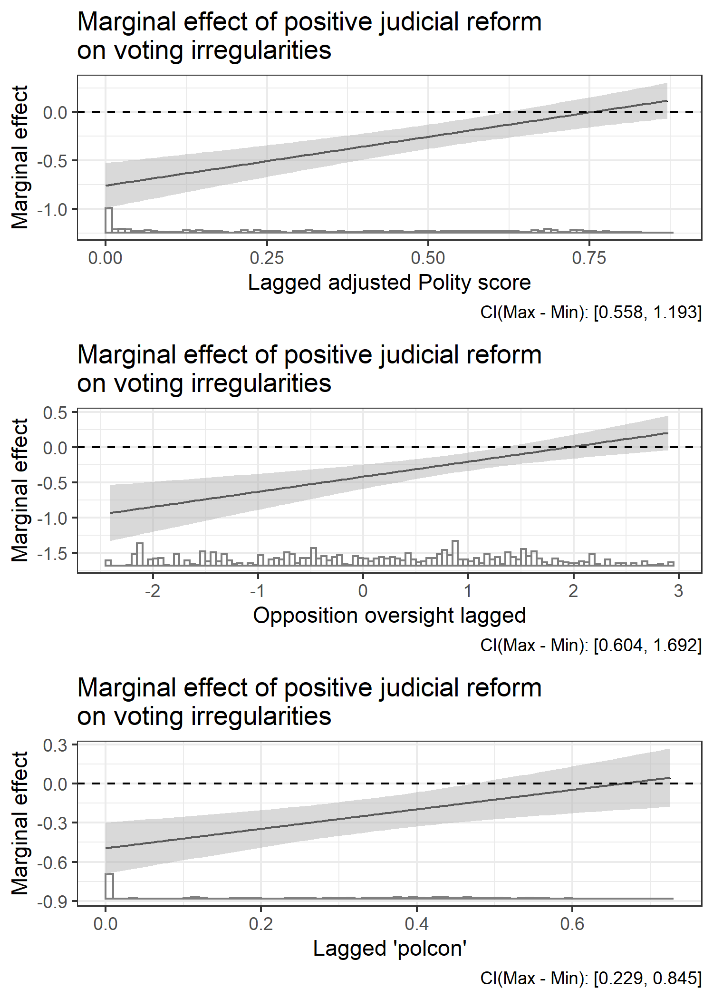

Figure A.3: Marginal effect of a major negative shock to judicial independence, conditional on Polity score and opposition oversight, using CBPS weighting. Shaded areas represent 95% confidence intervals adjusted for marginal effects

### Balance improvement for CBPS method

Balance improvement statistics for the CBPS approach are shown here. The upper panel of Table A.4 shows the means and standardized means for the explanatory and control variables after balancing; the lower panel shows the same information for the original data. The standardized means refer to the variable’s mean divided by its standard deviation; balance improvements on this measure illustrate how CBPS weighting accounts for the variance as well as means of the covariates (Imai & Ratkovic, 2014). By both measures, balance between treatment and control groups is improved across all variables.

|  |  |  |  |  |
| --- | --- | --- | --- | --- |
|  | | | | |
|  | Control means | Treatment means | Control std. means | Treatment std. means |
|  | | | | |
| Regime duration | 26.635 | 26.627 | 0.580 | 0.580 |
| Opposition autonomy | 1.144 | 1.145 | 0.947 | 0.948 |
| Education | 4.396 | 4.395 | 1.821 | 1.820 |
| Opposition oversight | 0.739 | 0.740 | 0.561 | 0.562 |
| GDP per capita (log) | 7.575 | 7.575 | 9.423 | 9.422 |
| Urban | 0.450 | 0.450 | 2.215 | 2.215 |
| High court independence | 0.401 | 0.402 | 0.350 | 0.351 |
| Low court independence | 0.663 | 0.664 | 0.614 | 0.615 |
| Exec. respect constitution | 0.956 | 0.957 | 0.871 | 0.872 |
| Alternative info | 0.714 | 0.715 | 2.814 | 2.815 |
| Legislative constraints on exec. | 0.590 | 0.590 | 2.169 | 2.170 |
| Transitional election | 0.022 | 0.022 | 0.094 | 0.094 |
|  | | | | |

|  |  |  |  |  |
| --- | --- | --- | --- | --- |
|  | | | | |
|  | Control means | Treatment means | Control std. means | Treatment std. means |
|  | | | | |
| Regime duration | 35.755 | 26.627 | 0.779 | 0.580 |
| Opposition autonomy | 0.579 | 1.145 | 0.479 | 0.948 |
| Education | 5.454 | 4.395 | 2.258 | 1.820 |
| Opposition oversight | -0.005 | 0.740 | -0.004 | 0.562 |
| GDP per capita (log) | 7.920 | 7.575 | 9.851 | 9.422 |
| Urban | 0.475 | 0.450 | 2.336 | 2.215 |
| High court independence | -0.289 | 0.402 | -0.252 | 0.351 |
| Low court independence | -0.137 | 0.664 | -0.127 | 0.615 |
| Exec. respect constitution | 0.261 | 0.957 | 0.237 | 0.872 |
| Alternative info | 0.541 | 0.715 | 2.130 | 2.815 |
| Legislative constraints on exec. | 0.428 | 0.590 | 1.574 | 2.170 |
| Transitional election | 0.069 | 0.022 | 0.288 | 0.094 |
|  | | | | |

Table A.4: Balance statistics for CBPS procedure

## Results of the selection model

The pre-processing techniques used in this study (weighting control observations by entropy balancing and covariate balancing propensity scores) can ameliorate concerns about endogeneity, but this comes at the risk that the underlying selection model may be misspecified. The CBPS approach has the advantage of producing doubly-robust estimates, meaning that the results are unbiased if either the propensity score or outcome model is correctly specified (Imai & Ratkovic, 2014), and the CBPS results mirror those of the entropy balancing models. However, in both cases, it is important to check the effectiveness of the underlying selection model. To evaluate the selection model, I report its results in the form of a standalone logit model of *positive judicial reform*, shown in Table A.5.

|  |  |  |  |
| --- | --- | --- | --- |
|  | | | |
|  | *Dependent variable:* | | |
|  |  | | |
|  | Positive judicial reform | | |
|  | (8) | (9) | (10) |
|  | | | |
| Regime duration | -0.002 | -0.001 | -0.001 |
|  | (0.003) | (0.003) | (0.003) |
|  |  |  |  |
| Opposition autonomy | -0.36** | -0.29** | -0.23* |
|  | (0.14) | (0.13) | (0.13) |
|  |  |  |  |
| Political openness | 1.00 |  |  |
|  | (0.72) |  |  |
|  |  |  |  |
| Opposition oversight |  | -0.07 |  |
|  |  | (0.18) |  |
|  |  |  |  |
| Political constraints |  |  | -1.12* |
|  |  |  | (0.58) |
|  |  |  |  |
| GDP per capita (log) | -1.06*** | -1.13*** | -1.10*** |
|  | (0.22) | (0.22) | (0.22) |
|  |  |  |  |
| Urban | 3.78*** | 3.85*** | 3.84*** |
|  | (0.83) | (0.83) | (0.84) |
|  |  |  |  |
| High court independence | 0.06 | 0.13 | 0.05 |
|  | (0.16) | (0.16) | (0.16) |
|  |  |  |  |
| Low court independence | 0.78*** | 0.74*** | 0.85*** |
|  | (0.18) | (0.18) | (0.18) |
|  |  |  |  |
| Transitional election | 0.26 | 0.56 | -0.04 |
|  | (0.35) | (0.38) | (0.35) |
|  |  |  |  |
| Exec. Respect for constitution | 0.16 | 0.19 | 0.17 |
|  | (0.15) | (0.15) | (0.14) |
|  |  |  |  |
| Alternative info | 1.57* | 2.28*** | 2.57*** |
|  | (0.82) | (0.77) | (0.73) |
|  |  |  |  |
| Education | -0.15** | -0.13** | -0.14** |
|  | (0.06) | (0.06) | (0.06) |
|  |  |  |  |
| Legislative constraints | -0.84 | -0.61 | -0.77 |
|  | (0.58) | (0.82) | (0.59) |
|  |  |  |  |
| Constant | 4.63*** | 4.85*** | 4.77*** |
|  | (1.39) | (1.53) | (1.39) |
|  |  |  |  |
|  | | | |
| Observations | 869 | 823 | 868 |
| Log Likelihood | -335.63 | -319.08 | -330.28 |
| Akaike Inf. Crit. | 697.27 | 664.16 | 686.56 |
|  | | | |
| *Note:* | *p<0.1; **p<0.05; ***p<0.01 | | |

Table A.5: Logit model of positive reform of judicial independence

Each of the covariates included in the model is theoretically justified as a predictor of assaults on judicial independence, as discussed in the main text. A chi-square test using the null and residual deviances from the logit models presented in Table A.5 produces a p-value approaching zero, indicating that the model fits the underlying data well. The results of the models themselves are also compelling. We see significant relationships between the dependent variable and the political variables *alternative sources of information, low-court independence,* and *opposition autonomy*. The negative relationship seen for income, which is unexpected, could indicate that more developed countries engaged in judicial reforms prior to entry into the dataset. Most importantly, we do not observe meaningful changes in the sign or size of control variables based on the inclusion of any particular measure of political competitiveness.

## Comparative constitutions project data

Following the coding rules in Melton and Ginsburg (2014), which also makes use of the CCP data, selection rules promote *de jure* independence if the appointment process involves a judicial council or two or more other institutions. Removal procedures promote *de jure* independence if judges cannot be removed, if removal requires super-majority approval in the legislature, if only the public or judicial councils can propose removal for ratification by another institution, or if judges can only be removed for crimes and other misconduct. For each country-year in the dataset, I take the sum the dummy variables indicating the presence of these features in the constitution regarding ordinary courts. The binary variable *positive constitutional reform* is then constructed by subtracting the current-year value from the lagged value for each country; it takes a value of 1 if there has been a positive change in *de jure* independence in the constitution, and 0 otherwise.

This ‘treatment’ indicator has advantages, namely its conceptual precision and ease of replicability for future studies, but it also has limitations. Changes to judicial institutions need not require amendments to the constitution; in Russia, for example, the specifics of judicial nomination, removal, and funding are set via statute.[1] Even in the United States, a country typically understood to have high *de jure* judicial independence, the size of the judiciary and the Supreme Court is set by legislation, and whether or not the opposition party has a voice in judicial selection is determined by Senate procedures. The V-Dem measure, by relying on coding by country experts, is more likely to capture such sub-constitutional reforms that can affect *de jure* independence. Moreover, constitutional reforms are rare; *positive constitutional reform* takes on a positive value only thirteen times in the year before an election in this dataset; the sum rises only to nineteen when the pre-election lag window is extended to two years.

This causes a lack of common support for the *opposition oversight variable*, as Figure A.4 illustrates. While positive constitutional reforms occur across most of the range of the *openness* and *constraints* mediator variables, they only occur at relatively high levels of *opposition oversight*. For this reason, I exclude *oversight* from models using CCP data as indicators of *de jure* independence.

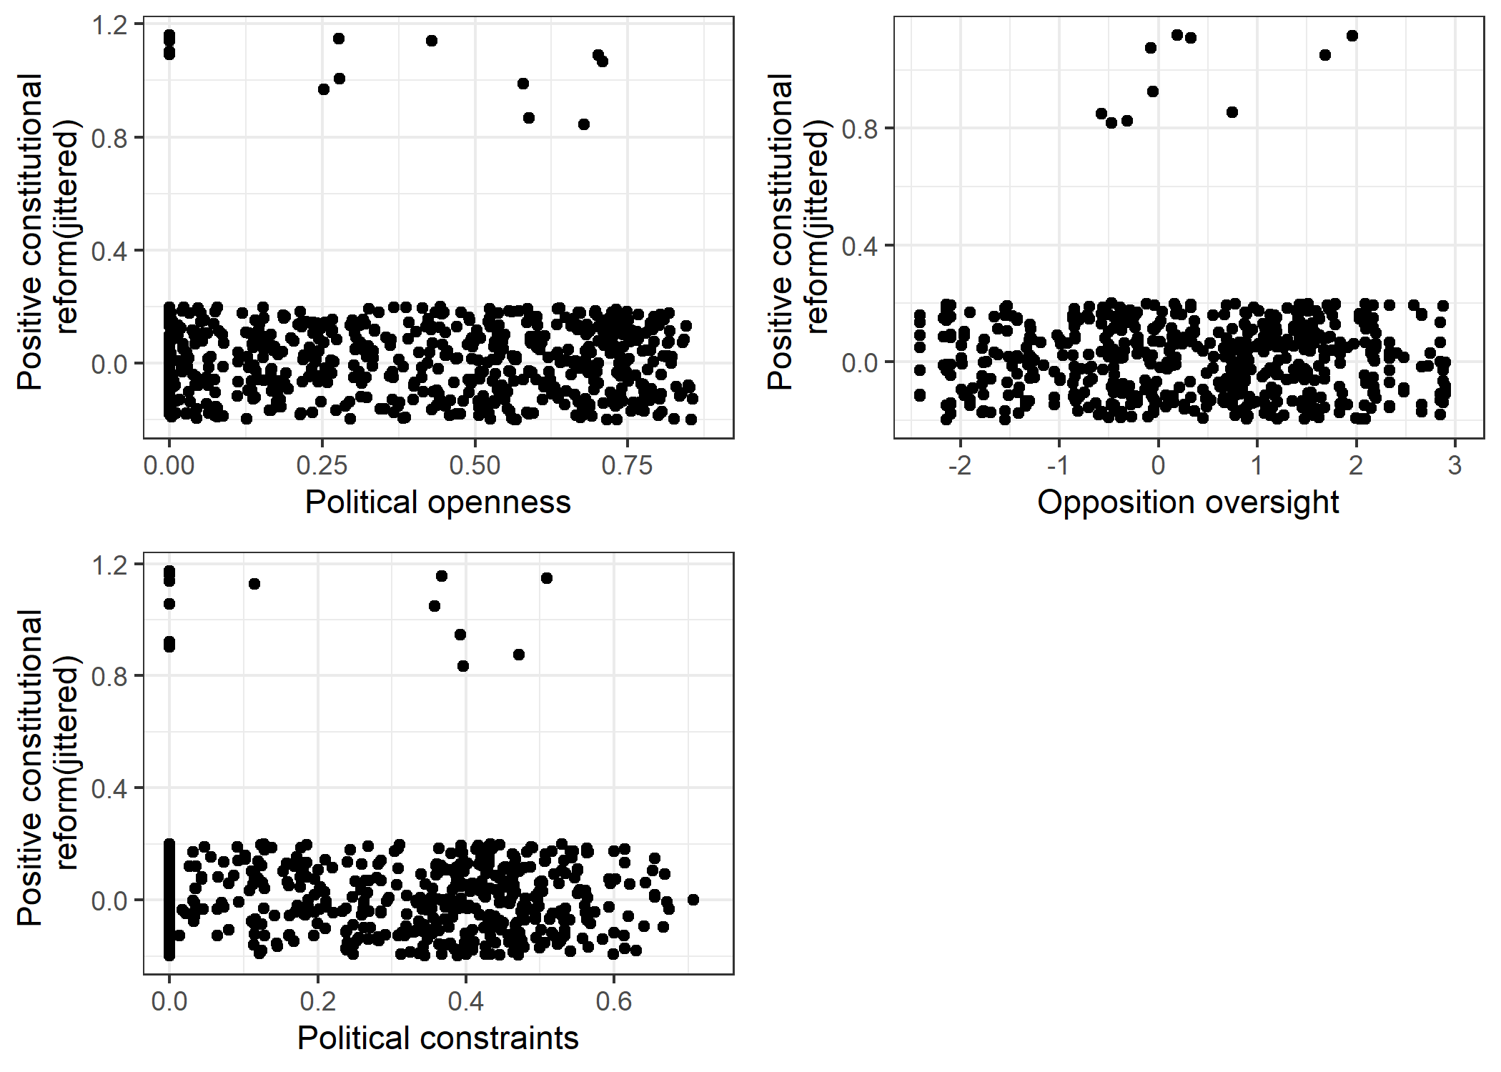

Figure A.4: Common support for treated observations across three moderator variables

The results of the models which make use of *positive constitutional reform* as the treatment variable after entropy balancing are presented in Table A.6, with the marginal effects for these models illustrated in Figure A.5. As the figure demonstrates, the results are largely consistent with those using the V-dem indicator—marginal effects are increasing with each measure of competitiveness, and are negative for low levels of competition. However, in contrast to the previous models, there is also a positive effect at high levels of competitiveness. What accounts for this difference? While this paper does not attempt to investigate the causes of statutory versus constitutional reforms to *de jure* independence, it is reasonable to assume that changes to the constitution are more likely to occur following a reordering of elite networks (Hale, 2014) or as a result of the negotiated transitions described by Magalhães (1999). In this case, it is likely that the increase in election manipulation observed in high-competition settings can be attributed to the insurance mechanism, in which outgoing elites look to secure their interests in a more redoubtable judicial branch as their electoral power declines. If true, the positive marginal effect is in comparison to weak incumbent elites who are unable to secure their interests on the courts; these elites would leave their agents exposed to increased risks of punishment and disfavor, leading to declines in their capacity to generate manipulation (Rundlett & Svolik, 2016).

|  |  |  |  |
| --- | --- | --- | --- |
|  | | | |
|  | *Dependent variable:* | | |
|  |  | | |
|  | Intentional voting irregularities | | |
|  | (11) | (12) | (13) |
|  | | | |
| Constitutional reform (sel. and rem.) | -0.400*** | 0.390*** | -0.428*** |
|  | (0.119) | (0.066) | (0.095) |
|  |  |  |  |
| Political openness | -0.994*** |  |  |
|  | (0.193) |  |  |
|  |  |  |  |
| Opposition oversight |  | -0.236*** |  |
|  |  | (0.043) |  |
|  |  |  |  |
| Political constraints |  |  | 0.565** |
|  |  |  | (0.228) |
|  |  |  |  |
| Executive election | 0.274*** | -0.083 | 0.211** |
|  | (0.097) | (0.097) | (0.095) |
|  |  |  |  |
| Proportional representation | 0.142 | -0.143 | 0.140 |
|  | (0.130) | (0.120) | (0.123) |
|  |  |  |  |
| Mixed electoral system | 0.032 | -0.325** | 0.424*** |
|  | (0.149) | (0.158) | (0.144) |
|  |  |  |  |
| GDP per capita | -0.547*** | -0.325** | -0.678*** |
|  | (0.140) | (0.136) | (0.126) |
|  |  |  |  |
| International observers | -0.103 | 0.091 | -0.011 |
|  | (0.104) | (0.093) | (0.097) |
|  |  |  |  |
| Negative judicial reform | -0.353*** | -0.517*** | -0.421*** |
|  | (0.115) | (0.114) | (0.109) |
|  |  |  |  |
| Judicial purge | -0.252*** | -0.472*** | -0.437*** |
|  | (0.065) | (0.058) | (0.059) |
|  |  |  |  |
| Court packing | -0.105 | -0.263*** | 0.081 |
|  | (0.071) | (0.080) | (0.066) |
|  |  |  |  |
| Constitutional reform (sel. and rem.):Political openness | 1.614*** |  |  |
|  | (0.250) |  |  |
|  |  |  |  |
| Constitutional reform (sel. and rem.) : Opposition oversight |  | 0.126 |  |
|  |  | (0.099) |  |
|  |  |  |  |
| Constitutional reform (sel. and rem.) : Political constraints |  |  | 2.144*** |
|  |  |  | (0.296) |
|  |  |  |  |
| Country fixed effects | Yes | Yes | Yes |
| Constant | 6.390*** | 4.706*** | 6.800*** |
|  | (2.195) | (1.675) | (1.251) |
|  |  |  |  |
|  | | | |
| Observations | 449 | 436 | 449 |
| R2 | 0.893 | 0.894 | 0.897 |
| Adjusted R2 | 0.863 | 0.864 | 0.869 |
|  | | | |
| *Note:* | *p<0.1; **p<0.05; ***p<0.01 | | |

Table A.6: Weighted OLS models of election fraud (entropy balanced weights). All non-electoral variables lagged by one year.

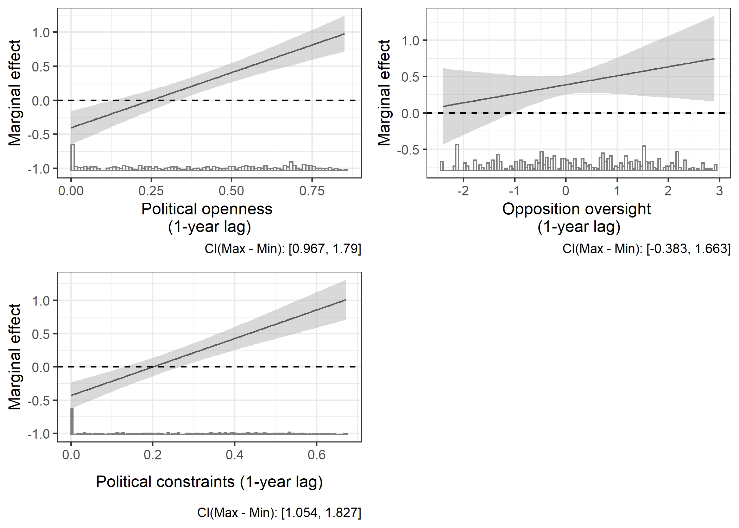

Figure A.5: Marginal effects of a positive judicial reform on intentional voting irregularities. Shaded areas represent 95% confidence intervals.

## Inter-temporal effects of reform within cases

A further implication of the theory presented in this paper is that *de jure* judicial reforms, by reducing electoral manipulation in some circumstances, will result in a better showing for opposition parties in the election at time one. This improved opposition strength leads to increased competitiveness of the election at time two, which in turn should cause the incumbent ruling party to dial up informal pressure on the courts. In places where the ruling party remains strong, this pressure then returns the courts to a more pliant mode, allowing for a return to baseline levels of election manipulation in the second election. In places where the opposition’s success in the first election allows it to more seriously contest the ruling party, we should expect the ruling party’s pressure campaign to be less effective, allowing for a more sustained reduction in election manipulation. Put in terms of an interaction effect, I expect that positive judicial reforms will have no significant effect on election fraud in the second election after reform in places where competition is low, and that the slope the marginal effects will be negative.

I check this implication by running the same models as those presented in Table 2 in the main text, with entropy-balanced weights for judicial reform, with a one-election lead value for *intentional voting irregularities* as the dependent variable. Control variables are also measured on a one-year lead, so that they refer to the election at hand in the model. Selection variables in the entropy-balancing stage remain lagged one year behind the reform. The results in Table A.7 and Figure A.6 are mixed, but generally supportive of the predictions outlined above. Model 14, which uses *political competition*  as the moderator variable, is the most supportive; the effect of judicial reform at time one is insignificant for low-competition settings, but is significant and negative at higher levels of competition. Model 15 is also supportive, but with a null effect across all levels of *legislative oversight*. Model 16 does not support the predicted effects for elections at time two; a prior judicial reform is associated with reduced fraud across all levels of *political constraints*. Further research could investigate the circumstances under which increased competition based on positive judicial reform ‘tips over’ into durable opposition strength, and the circumstances under which regime pressure is successful at defusing such movements.

|  |  |  |  |
| --- | --- | --- | --- |
|  | | | |
|  | *Dependent variable:* | | |
|  |  | | |
|  | Intentional voting irregularities (time 2) | | |
|  | (14) | (15) | (16) |
|  | | | |
| Positive judicial reform | -0.12 | -0.13 | -0.25** |
|  | (0.14) | (0.09) | (0.12) |
|  |  |  |  |
| Political competition | -1.58*** |  |  |
|  | (0.15) |  |  |
|  |  |  |  |
| Opposition oversight |  | -0.36*** |  |
|  |  | (0.04) |  |
|  |  |  |  |
| Political constraints |  |  | -0.70*** |
|  |  |  | (0.19) |
|  |  |  |  |
| Executive election | -0.17** | -0.06 | -0.08 |
|  | (0.08) | (0.08) | (0.09) |
|  |  |  |  |
| GDP per capita | -0.02 | -0.24*** | -0.24*** |
|  | (0.08) | (0.08) | (0.08) |
|  |  |  |  |
| International monitors | -0.31*** | -0.22*** | -0.36*** |
|  | (0.06) | (0.06) | (0.06) |
|  |  |  |  |
| Proportional representation | -0.21** | -0.12 | -0.09 |
|  | (0.10) | (0.10) | (0.11) |
|  |  |  |  |
| Mixed electoral system | -0.03 | -0.06 | 0.02 |
|  | (0.11) | (0.11) | (0.12) |
|  |  |  |  |
| Negative judicial reform | -0.16 | -0.08 | -0.14 |
|  | (0.12) | (0.12) | (0.13) |
|  |  |  |  |
| Judicial purges | -0.25*** | -0.27*** | -0.22*** |
|  | (0.06) | (0.06) | (0.07) |
|  |  |  |  |
| Court packing | -0.15** | -0.11 | -0.25*** |
|  | (0.08) | (0.07) | (0.08) |
|  |  |  |  |
| Positive judicial reform : Pol. Comp. | -0.12 |  |  |
|  | (0.22) |  |  |
|  |  |  |  |
| Positive judicial reform : Opp. oversight |  | -0.04 |  |
|  |  | (0.06) |  |
|  |  |  |  |
| Positive judicial reform: Pol. constraints |  |  | -0.04 |
|  |  |  | (0.26) |
|  |  |  |  |
| Country fixed effects | Yes | Yes | Yes |
|  |  |  |  |
| Constant | 2.76*** | 3.94*** | 3.87*** |
|  | (0.65) | (0.69) | (0.69) |
|  |  |  |  |
|  | | | |
| Observations | 648 | 607 | 649 |
| R2 | 0.88 | 0.89 | 0.85 |
| Adjusted R2 | 0.85 | 0.87 | 0.82 |
|  | | | |
| *Note:* | *p<0.1; **p<0.05; ***p<0.01 | | |

Table A.7: Weighted OLS (entropy-balanced weights) models of election fraud in second election after reforms. All non-judicial variables are lagged one year behind the second election, except *executive election*  and *international monitors*.

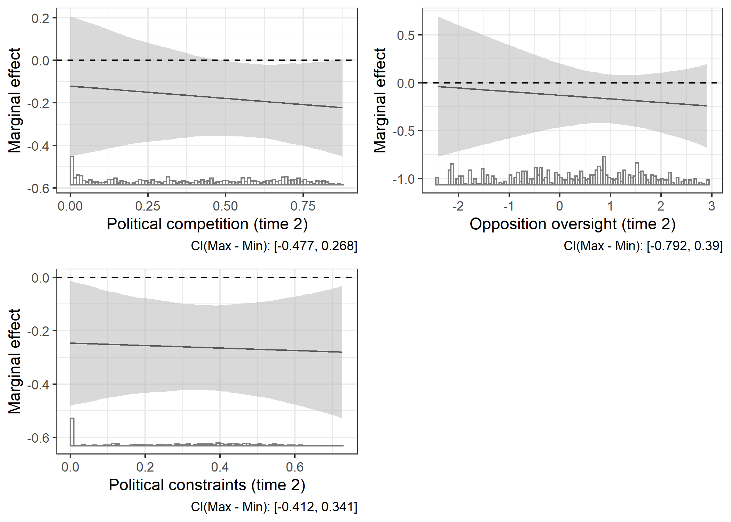

Figure A.6: Marginal effects of a positive judicial reform on intentional voting irregularities. Shaded areas represent 95% confidence intervals

Given that *de jure* judicial reforms result in reduced manipulation in low-competition settings in the short-term, but not—apparently—in subsequent elections raises another testable implication of this theory. Any potentially destabilizing effect of positive judicial reforms due to reduced election manipulation in low-competition environments is likely to be felt in the first subsequent election, rather than in later contests after pressure is applied. To test this implication, I use the binary *democratic transition* variable in V-Dem as a dependent variable (Boix et al., 2013). I test three alternative models, with the dependent variable leading the reform by one year, three years, and five years. The models include control variables for *regime duration*, and *GDP per capita*. These controls lead the judicial reform by the same number of years as the dependent variable. The models also control for indicators of attacks on the judiciary. Selection variables for *positive judicial reform* remain the same. For simplification, I only run these models using the *political openness variable*. Since the destabilizing effect is posited to occur due to better-than-expected opposition results in election years, I interact the reform and openness variables with an indicator for *election years*. I expect that judicial reform will increase the risk of transition in immediately subsequent election years, but not thereafter. I also expect there will be no effect for transitions in ordinary years, since it is elections that are the mechanism for revealing information about opposition strength in the absence of election fraud.

|  |  |  |  |
| --- | --- | --- | --- |
|  | | | |
|  | *Dependent variable:* | | |
|  |  | | |
|  | Democratic transition | Democratic transition (3-year lead) | Democratic transition (5-year lead) |
|  | (1) | (2) | (3) |
|  | | | |
| Positive judicial reform | 0.03* | 0.01 | 0.002 |
|  | (0.02) | (0.02) | (0.02) |
|  |  |  |  |
| Political openness | -0.16*** |  |  |
|  | (0.02) |  |  |
|  |  |  |  |
| Election year | 0.05*** |  |  |
|  | (0.02) |  |  |
|  |  |  |  |
| Regime duration | -0.002*** |  |  |
|  | (0.0002) |  |  |
|  |  |  |  |
| GDP per capita | 0.03*** |  |  |
|  | (0.01) |  |  |
|  |  |  |  |
| Political openness (3-year lead) |  | -0.04 |  |
|  |  | (0.02) |  |
|  |  |  |  |
| Election-year (3-year lead) |  | 0.11*** |  |
|  |  | (0.02) |  |
|  |  |  |  |
| Regime duration (3-year lead) |  | -0.001*** |  |
|  |  | (0.0002) |  |
|  |  |  |  |
| GDP per capita (3-year lead) |  | 0.01 |  |
|  |  | (0.01) |  |
|  |  |  |  |
| Political openness (5-year lead) |  |  | -0.06** |
|  |  |  | (0.03) |
|  |  |  |  |
| Election-year (5-year lead) |  |  | 0.10*** |
|  |  |  | (0.02) |
|  |  |  |  |
| Regime duration (5-year lead) |  |  | -0.002*** |
|  |  |  | (0.0002) |
|  |  |  |  |
| GDP per capita (5-year lead) |  |  | 0.01 |
|  |  |  | (0.01) |
|  |  |  |  |
| Negative judicial reform | -0.002 | 0.03* | 0.04** |
|  | (0.02) | (0.02) | (0.02) |
|  |  |  |  |
| Judicial purge | -0.01* | -0.02*** | -0.04*** |
|  | (0.01) | (0.01) | (0.01) |
|  |  |  |  |
| Court packing | 0.02** | 0.01 | 0.02** |
|  | (0.01) | (0.01) | (0.01) |
|  |  |  |  |
| Positive jud. Reform : Political openness | -0.05 |  |  |
|  | (0.03) |  |  |
|  |  |  |  |
| Positive jud. reform : Election year | 0.11*** |  |  |
|  | (0.02) |  |  |
|  |  |  |  |
| Political openness : Election year | -0.03 |  |  |
|  | (0.03) |  |  |
|  |  |  |  |
| Positive jud. reform : Political openness : Election year | -0.18*** |  |  |
|  | (0.04) |  |  |
|  |  |  |  |
| Positive jud. reform : Political openness (3-year lead) |  | -0.01 |  |
|  |  | (0.03) |  |
|  |  |  |  |
| Positive jud. reform : Election year (3-year lead) |  | -0.05* |  |
|  |  | (0.03) |  |
|  |  |  |  |
| Political openness (3-year lead) : Election year (3-year lead) |  | -0.08*** |  |
|  |  | (0.03) |  |
|  |  |  |  |
| Positive jud. reform : Political openness (3-year lead) : Election year (3-year lead) |  | 0.02 |  |
|  |  | (0.05) |  |
|  |  |  |  |
| Positive jud. reform : Political openness (5-year lead) |  |  | 0.01 |
|  |  |  | (0.03) |
|  |  |  |  |
| Positive jud. reform : Election year (5-year lead) |  |  | -0.08*** |
|  |  |  | (0.03) |
|  |  |  |  |
| Political openness (5-year lead) : Election year (5-year lead) |  |  | -0.08*** |
|  |  |  | (0.03) |
|  |  |  |  |
| Positive jud. reform : Political openness (5-year lead) : Election year (5-year lead) |  |  | 0.10** |
|  |  |  | (0.05) |
|  |  |  |  |
| Country fixed effects | Yes | Yes | Yes |
| Constant | -0.15 | -0.08 | 0.21*** |
|  | (0.09) | (0.10) | (0.08) |
|  |  |  |  |
|  | | | |
| Observations | 2,903 | 2,547 | 2,316 |
| Log Likelihood | 146.58 | 312.29 | 340.79 |
| Akaike Inf. Crit. | -29.16 | -368.58 | -437.58 |
|  | | | |
| *Note:* | *p<0.1; **p<0.05; ***p<0.01 | | |

Table A.8: Entropy balanced logit models

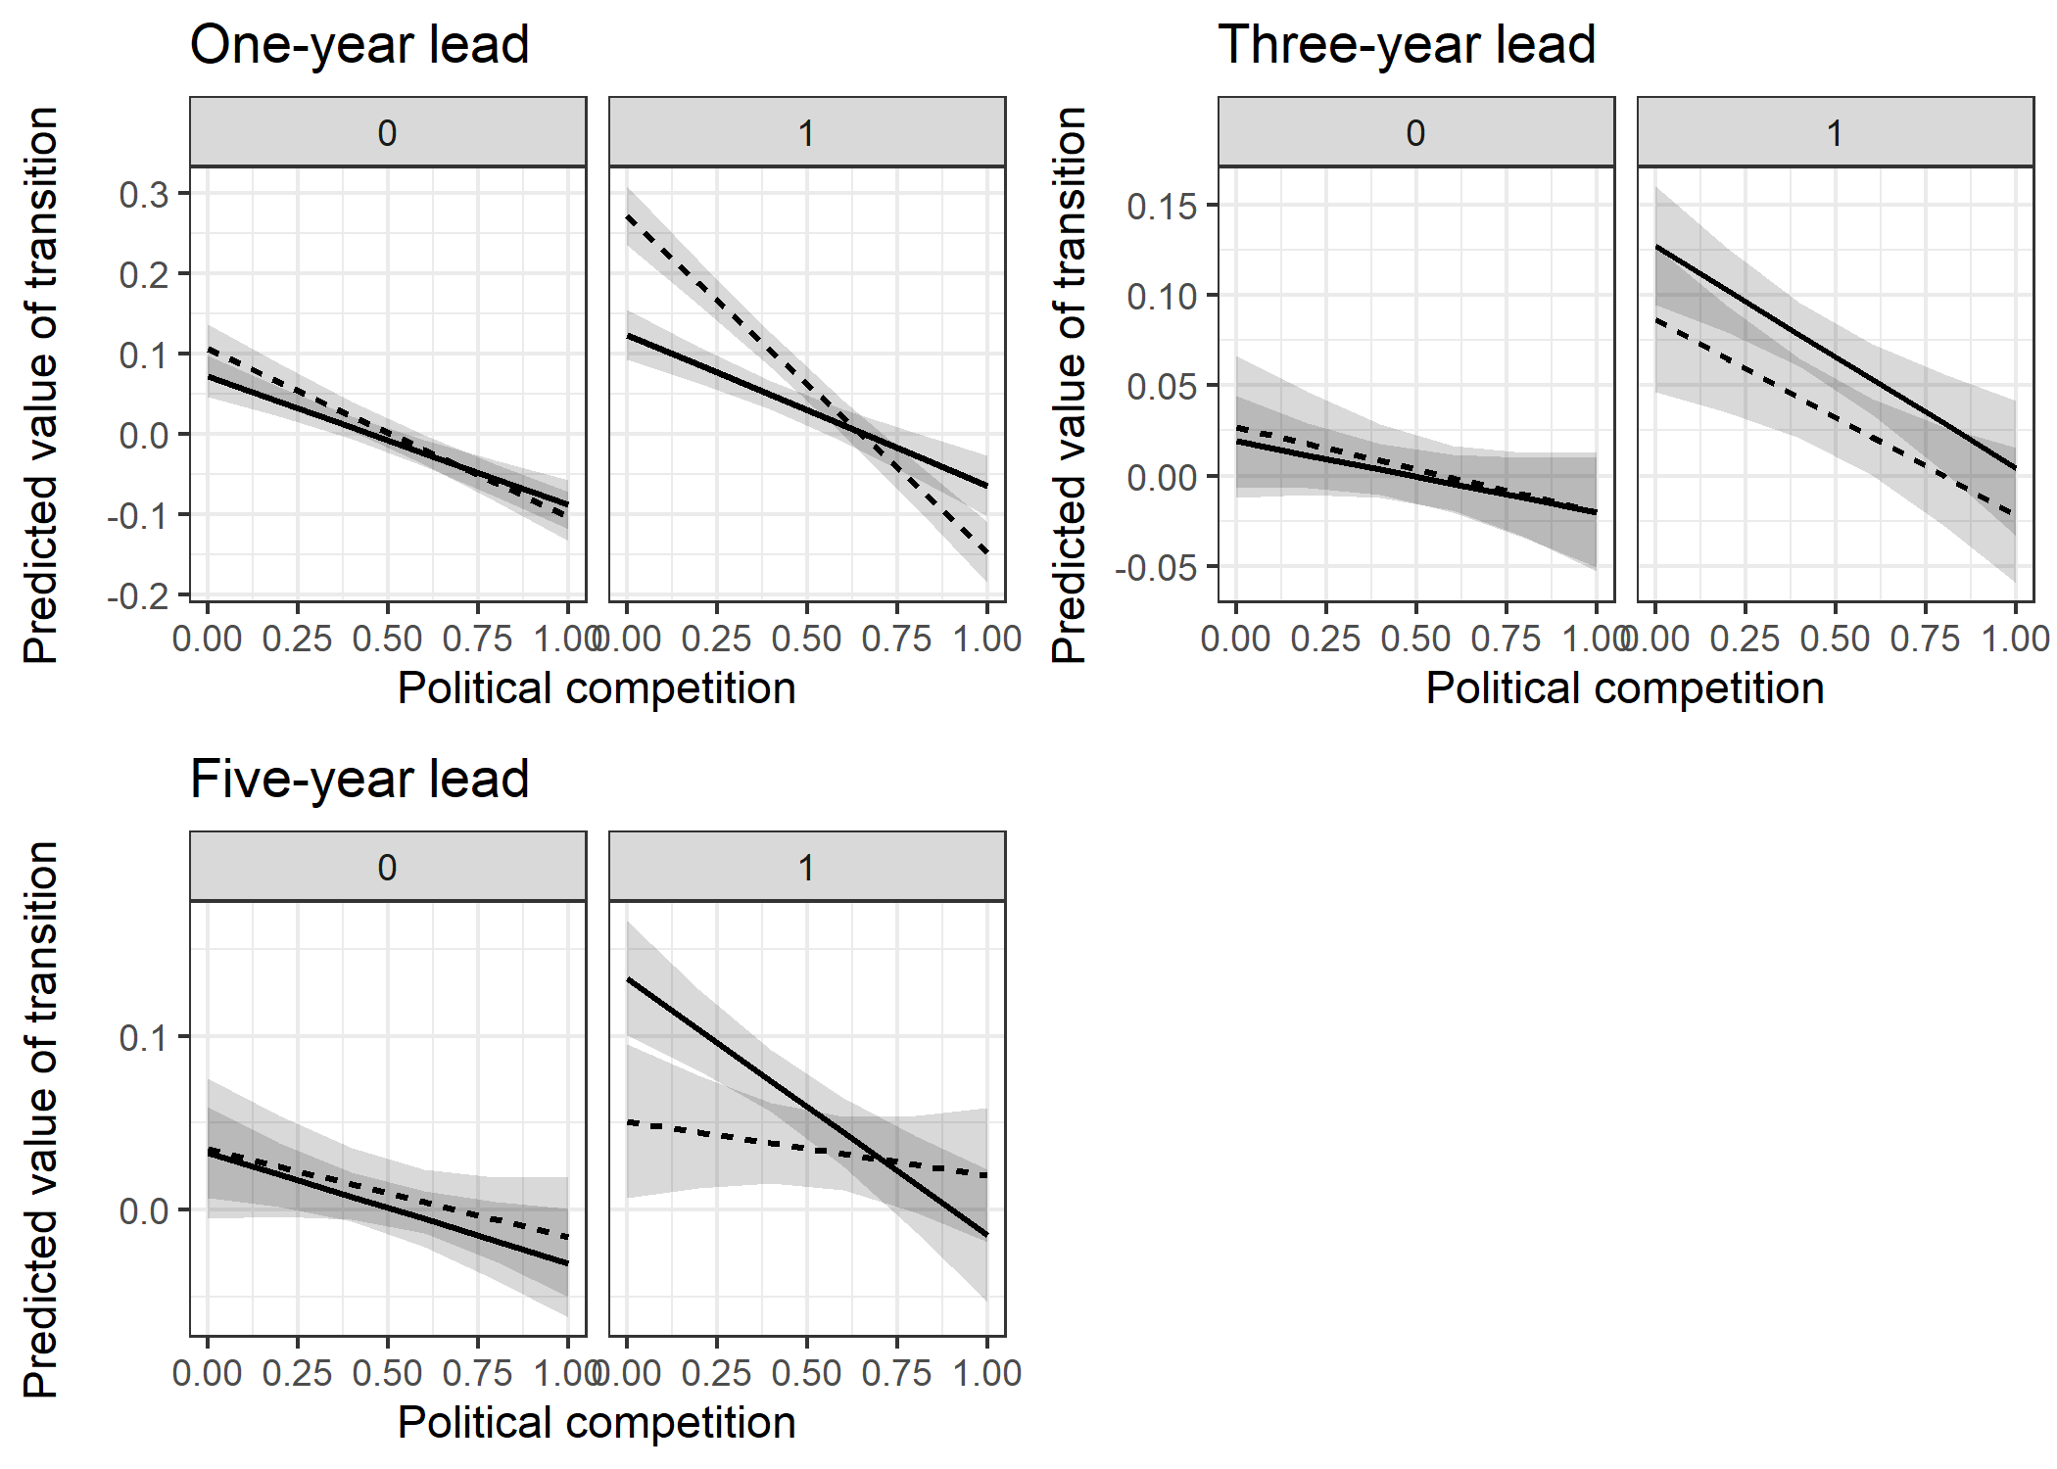

Figure A.7: Marginal effects of judicial reform on regime transition one year, three years, and five years from reform. Dashed lines indicate the presence of judicial reform; solid lines represent no reform. Left panels (marked ‘0’) indicate ordinary years, right panels (marked ‘1’) represent election years. Control variables held at the mean.

Figure A.7, which plots the three-way interaction effects, shows that these predictions are upheld. In election years, reform is associated with a significant and substantively large increase in the risk of regime transition in low-openness settings one year after reform. After three years, there is no significant difference between cases with and without judicial reforms during election years. Finally, by five years, the relationship is reversed—the risk of regime change is significantly lower in low-openness settings that enacted a judicial reform compared to those that did not. This is in keeping with the theory that ruling parties in non-democracies can reap long-term benefits from empowering their courts, but that such an approach entails the short-term risks described in this article.

## Judicial independence and the risk of post-election protest

In the main text of the paper, the findings are interpreted as supportive of principal-agent theories of election manipulation and as unsupportive of models that posit that protest risk is the main deterrent of election fraud. To further test this interpretation, the models in this section use a measure of *anti-fraud protests* as a dependent variable. These models are not a complete review of the question, which is deserving of more thorough academic study; nevertheless, taken in concert with the findings in the main paper and other sections of this appendix, the results offer further evidence that protest-risk does not drive the outcomes in the main study.

To build the models, I combine data from V-Dem with data from the National Elections Across Democracy and Autocracy (NELDA) dataset (Hyde & Marinov, 2012), which includes a measure of post-election protests that include allegations of fraud. Specifically, the variable *anti-fraud protests* takes on a value of one if the variable ‘nelda30’ takes on a value of one[2], and takes on a value of zero if there were no protests or if they did not include allegations of manipulation. I make use of the same selection variables for *positive judicial reform* as have been used in all prior models. Finally, I include several control variables that could also account for the occurrence of post-election protest: the winner’s margin of victory, the openness of civil society participation, GDP growth rate, whether the election is for the executive or legislature, a physical repression index, and a categorical measure of regime type.[3] All of these measures are taken from V-Dem, and with the exception of *executive election* are lagged by one year. The models also include country fixed effects.

In these models, I interact the judicial reform treatment variable with the measure of *intentional voting irregularities* and the underlying level of competition. Table A.9 and Figure A.8 present the results of these models. The marginal effects in Figure A.8 are especially useful for teasing out the implications of the three-way interaction terms. In each sub-figure, the left panel holds *judicial reform* at zero, while the right panel holds it at one. The x-axis refers to the measure of competitiveness used in the model. To capture the extreme cases, the extent of election is rigging is held at its minimum (red line) and maximum (blue line) values. In all three cases, there is no evidence that more formally independent courts increase protest risk when elections are rigged. In fact, positive judicial reforms appear to *reduce* the risk of post-election protest, especially in lower-competition regimes.

|  |  |  |  |
| --- | --- | --- | --- |
|  | | | |
|  | *Dependent variable:* | | |
|  |  | | |
|  | Anti-fraud protests | | |
|  | (20) | (21) | (22) |
|  | | | |
| Positive judicial reform | -0.01 | -0.02 | -0.03 |
|  | (0.08) | (0.06) | (0.06) |
|  |  |  |  |
| Intentional voting irregularities | 0.19*** | 0.21*** | 0.14*** |
|  | (0.05) | (0.03) | (0.04) |
|  |  |  |  |
| Political openness | 0.28** |  |  |
|  | (0.12) |  |  |
|  |  |  |  |
| Opposition oversight |  | -0.01 |  |
|  |  | (0.03) |  |
|  |  |  |  |
| Political constraints |  |  | 0.22* |
|  |  |  | (0.12) |
|  |  |  |  |
| Winner margin | 0.14 | 0.14 | 0.15 |
|  | (0.10) | (0.11) | (0.10) |
|  |  |  |  |
| Civil society openness | 0.13 | 0.27* | 0.20 |
|  | (0.15) | (0.16) | (0.14) |
|  |  |  |  |
| GDP growth rate | 0.26 | 0.21 | 0.22 |
|  | (0.17) | (0.17) | (0.17) |
|  |  |  |  |
| Executive election | 0.01 | 0.01 | 0.03 |
|  | (0.03) | (0.03) | (0.03) |
|  |  |  |  |
| Physical integrity | 0.15 | 0.23 | 0.20 |
|  | (0.14) | (0.15) | (0.13) |
|  |  |  |  |
| Closed authoritarian regime | 0.16 | 0.10 | 0.07 |
|  | (0.10) | (0.10) | (0.09) |
|  |  |  |  |
| Electoral authoritarian regime | -0.09* | -0.03 | -0.06 |
|  | (0.05) | (0.05) | (0.04) |
|  |  |  |  |
|  |  |  |  |
|  |  |  |  |
| Pos. judicial reform:Intentional voting irreg. | -0.15* | -0.07 | -0.09 |
|  | (0.09) | (0.05) | (0.07) |
|  |  |  |  |
| Pos. judicial reform:Pol. openness | -0.06 |  |  |
|  | (0.14) |  |  |
|  |  |  |  |
| Intentional voting irreg.:Pol. openness | 0.02 |  |  |
|  | (0.07) |  |  |
|  |  |  |  |
| Pos. judicial reform:Intentional voting irreg.:Pol. openness | 0.10 |  |  |
|  | (0.14) |  |  |
|  |  |  |  |
| Pos. judicial reform : Opposition oversight |  | 0.01 |  |
|  |  | (0.04) |  |
|  |  |  |  |
| Intentional voting irreg.: Opposition oversight |  | -0.02 |  |
|  |  | (0.02) |  |
|  |  |  |  |
| Pos. judicial reform:Intentional voting irreg.: Opposition oversight |  | 0.01 |  |
|  |  | (0.03) |  |
|  |  |  |  |
| Positive judicial reform:Pol. constraints |  |  | -0.08 |
|  |  |  | (0.15) |
|  |  |  |  |
| Intentional voting irreg.:Pol. constraints |  |  | 0.16* |
|  |  |  | (0.10) |
|  |  |  |  |
| Pos. judicial reform:Intentional voting irreg.:Pol. constraints |  |  | -0.02 |
|  |  |  | (0.17) |
|  |  |  |  |
| Constant | 0.06 | 0.02 | 0.05 |
|  | (0.14) | (0.15) | (0.14) |
|  |  |  |  |
|  | | | |
| Observations | 806 | 765 | 807 |
| Log Likelihood | -533.16 | -521.50 | -535.37 |
| Akaike Inf. Crit. | 1,296.33 | 1,273.01 | 1,300.73 |
|  | | | |
| *Note:* | *p<0.1; **p<0.05; ***p<0.01 | | |

Table A.9: Logit model of post-election anti-fraud protests, with entropy balanced weights.

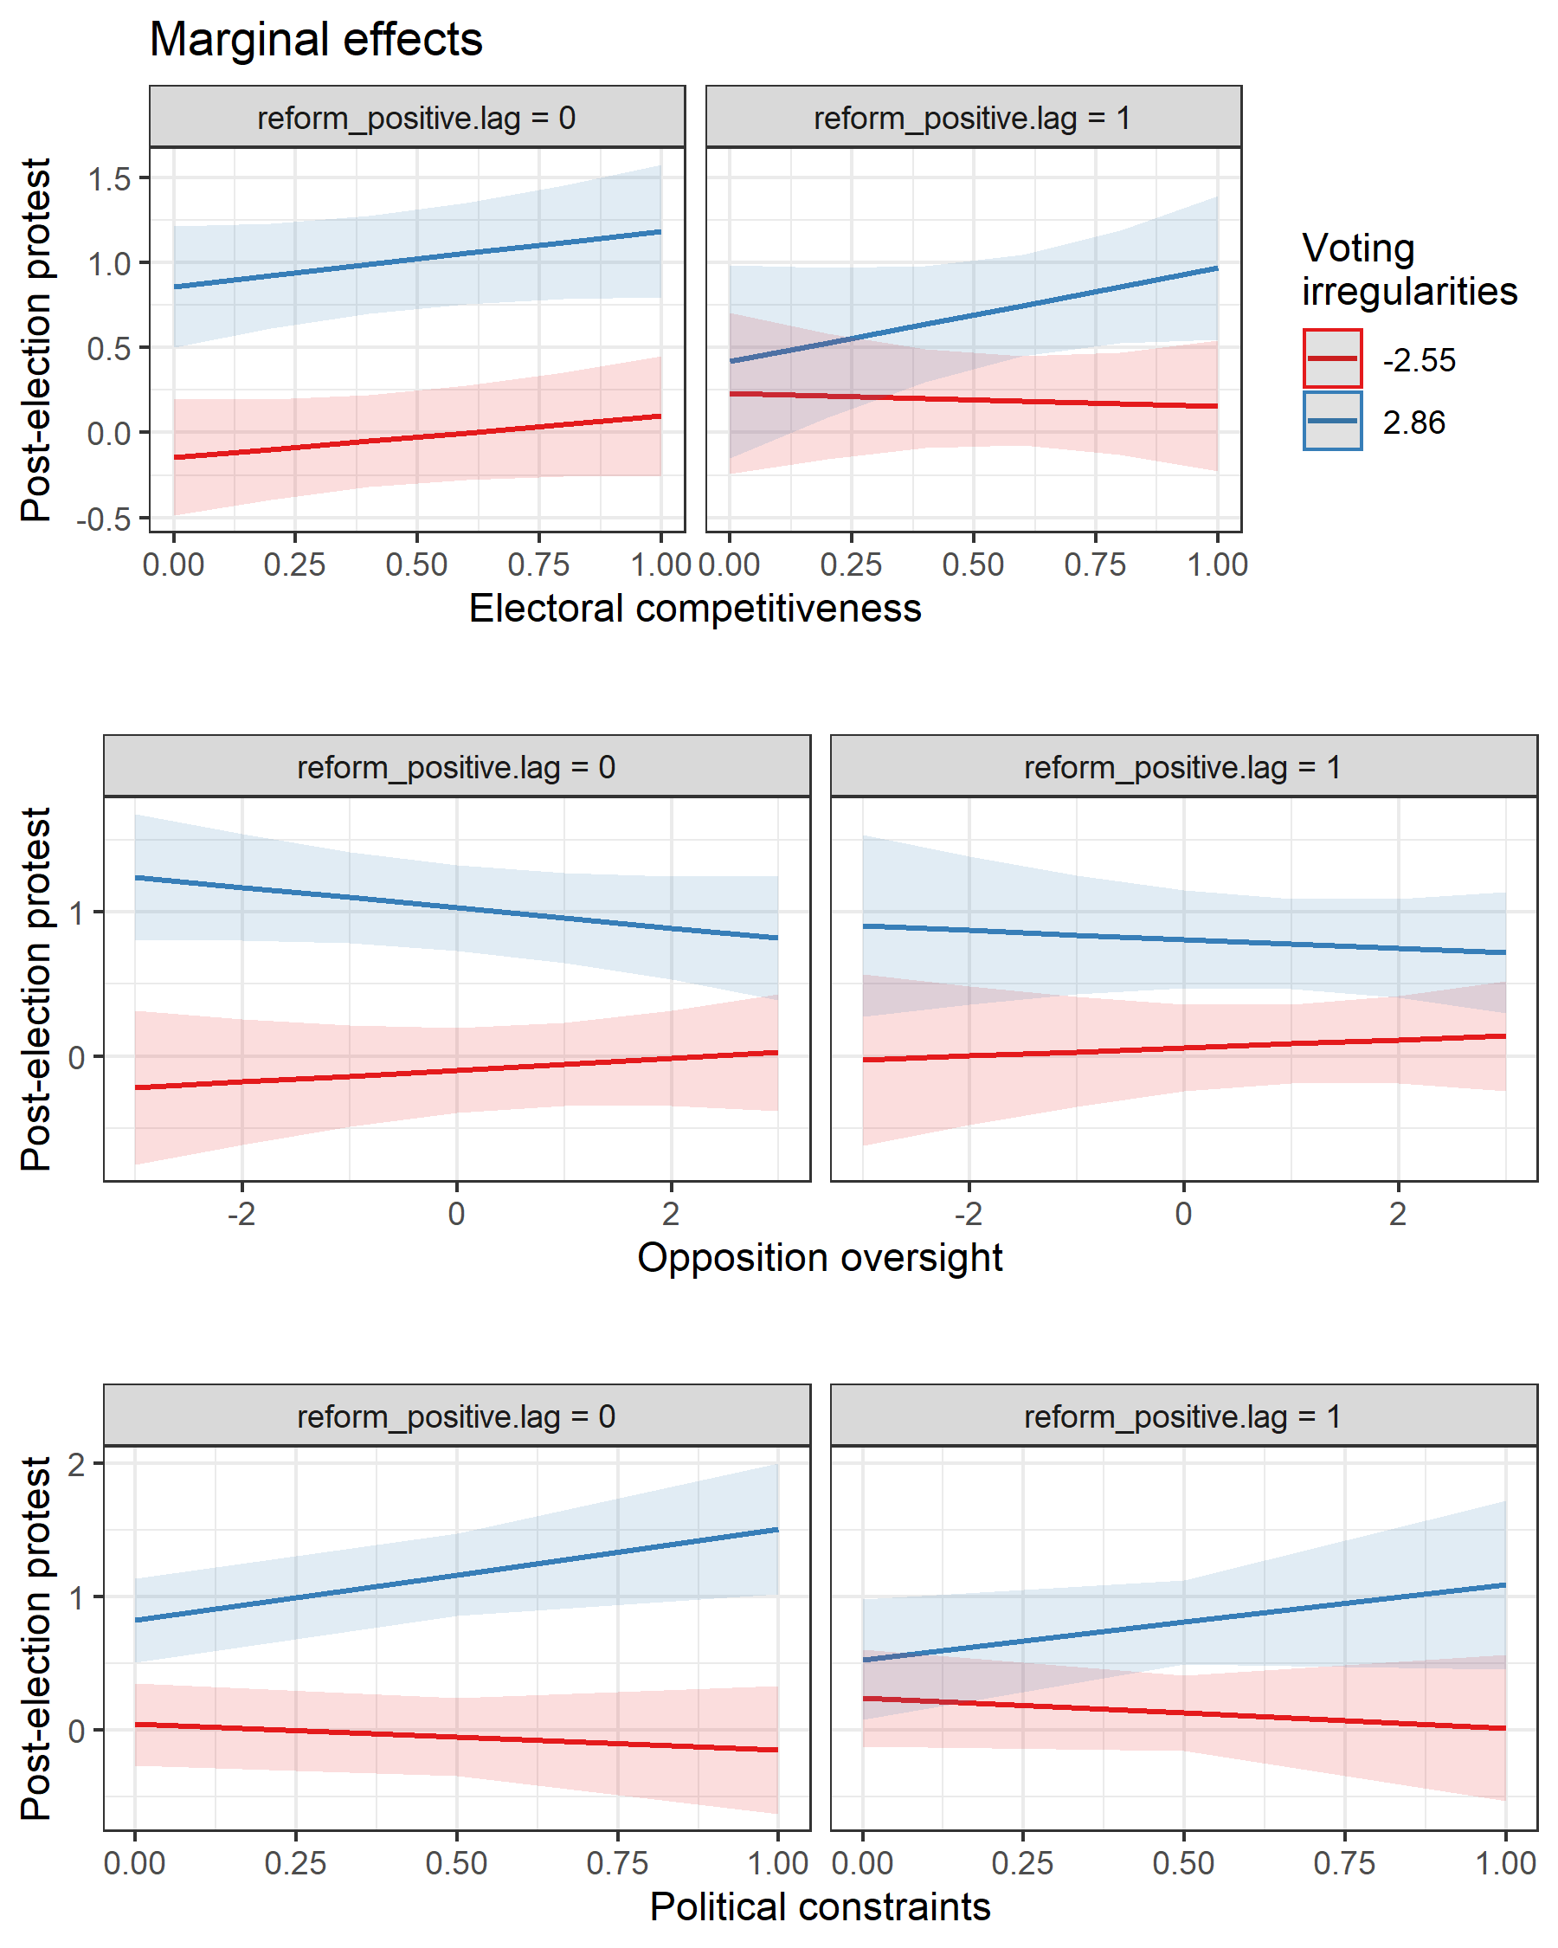

Figure A.8: Marginal effects of a positive judicial reform on anti-fraud protests. Shaded areas represent 95% confidence intervals

## Regression table for electoral court models

Table A.10 provides the regression summaries associated with Figure 2 in the main text.

|  |  |  |  |
| --- | --- | --- | --- |
|  | | | |
|  | *Dependent variable:* | | |
|  |  | | |
|  | Intentional voting irregularities | | |
|  | (23) | (24) | (25) |
|  | | | |
| Political openness | -0.28 |  |  |
|  | (0.23) |  |  |
|  |  |  |  |
| Opposition oversight |  | -0.31*** |  |
|  |  | (0.04) |  |
|  |  |  |  |
| Political constraints |  |  | -0.20 |
|  |  |  | (0.25) |
|  |  |  |  |
| Positive judicial reform | -0.99*** | -0.56*** | -0.71*** |
|  | (0.16) | (0.12) | (0.12) |
|  |  |  |  |
| Electoral court | 1.32*** | 1.09*** | 1.07*** |
|  | (0.36) | (0.35) | (0.39) |
|  |  |  |  |
| Electoral court independence | -0.33*** | -0.38*** | -0.37*** |
|  | (0.07) | (0.07) | (0.07) |
|  |  |  |  |
| Political openness : Positive judicial reform | 1.26*** |  |  |
|  | (0.28) |  |  |
|  |  |  |  |
| Opposition oversight : Positive judicial reform |  | 0.22*** |  |
|  |  | (0.06) |  |
|  |  |  |  |
| Political constraints : Positive judicial reform |  |  | 1.15*** |
|  |  |  | (0.31) |
|  |  |  |  |
| Positive judicial reform : Electoral court | 0.78** | 0.92*** | 1.02*** |
|  | (0.33) | (0.28) | (0.31) |
|  |  |  |  |
| Political openness : Electoral court | -0.93** |  |  |
|  | (0.42) |  |  |
|  |  |  |  |
| Political openness : Positive judicial reform : Electoral court | -0.75 |  |  |
|  | (0.57) |  |  |
|  |  |  |  |
| Opposition oversight : Electoral court |  | 0.16 |  |
|  |  | (0.11) |  |
|  |  |  |  |
| Opposition oversight : Positive judicial reform : Electoral court |  | -0.41*** |  |
|  |  | (0.16) |  |
|  |  |  |  |
| Political constraints : Electoral court |  |  | -0.32 |
|  |  |  | (0.49) |
|  |  |  |  |
| Political constraints : Positive judicial reform : Electoral court |  |  | -1.48** |
|  |  |  | (0.63) |
|  |  |  |  |
| Country fixed effects | Yes | Yes | Yes |
|  | | | |
| Observations | 506 | 478 | 506 |
| R2 | 0.90 | 0.92 | 0.90 |
| Adjusted R2 | 0.88 | 0.89 | 0.87 |
| Residual Std. Error | 0.23 (df = 393) | 0.22 (df = 365) | 0.23 (df = 393) |
| F Statistic | 33.03*** (df = 112; 393) | 36.11*** (df = 112; 365) | 32.48*** (df = 112; 393) |
|  | | | |
| *Note:* | *p<0.1; **p<0.05; ***p<0.01 | | |

Table A.10: Weighted OLS models of election fraud (entropy balanced weights). All variables 1-year lagged, except *executive election*, *proportional electoral system*, *mixed electoral system*, and *international observers*. Control variables excluded from the table, but are included in the models.

## Alternative coding of democracy

To confirm that the results do not depend on specific features of the dataset based on the *competitiveness of participation* measure of democracy, I also use the binary coding of democracy developed by Cheibub et al (Cheibub et al., 2010). Their coding scheme classifies regimes as democracies if they meet four conditions: 1) the chief executive must be popularly elected or chosen by a popularly elected body, 2) the legislature must be popularly elected, 3) there must be more than one party competing in elections, and 4) at least one alternation in power under the same electoral rules must have occurred. The following models exclude all cases that qualify as democracies under this coding scheme. As Table A.11 shows, it is a more restrictive dataset, since it will exclude some country-years where alternation under the status-quo electoral rules has not yet taken place. Nonetheless, as Figure A.9 shows, the results mirror those in the main text.

|  |  |  |  |
| --- | --- | --- | --- |
|  | | | |
|  | | | |
|  | *Dependent variable:* | | |
|  |  | | |
|  | Intentional voting irregularities | | |
|  | (26) | (27) | (28) |
|  | | | |
| Positive judicial reform | -0.93*** | -0.61*** | -0.87*** |
|  | (0.15) | (0.12) | (0.13) |
|  |  |  |  |
| Political openness | -0.44 |  |  |
|  | (0.33) |  |  |
|  |  |  |  |
| Opposition oversight |  | -0.30*** |  |
|  |  | (0.08) |  |
|  |  |  |  |
| Political constraints |  |  | -1.43*** |
|  |  |  | (0.27) |
|  |  |  |  |
| Executive election | -0.03 | -0.10 | -0.05 |
|  | (0.06) | (0.07) | (0.06) |
|  |  |  |  |
| PR system | -0.39** | -0.48*** | -0.36** |
|  | (0.15) | (0.15) | (0.14) |
|  |  |  |  |
| Mixed electoral system | -0.04 | -0.07 | 0.11 |
|  | (0.10) | (0.09) | (0.09) |
|  |  |  |  |
| GDP per capita (log) | 0.07 | 0.001 | 0.06 |
|  | (0.08) | (0.09) | (0.08) |
|  |  |  |  |
| International observers | -0.42*** | -0.37*** | -0.31*** |
|  | (0.06) | (0.07) | (0.07) |
|  |  |  |  |
| Negative judicial reform | 0.43** | 0.40** | 0.51** |
|  | (0.17) | (0.19) | (0.20) |
|  |  |  |  |
| Judicial purges | -0.09 | -0.11 | -0.13 |
|  | (0.12) | (0.13) | (0.13) |
|  |  |  |  |
| Court packing | -0.03 | -0.12 | 0.12 |
|  | (0.12) | (0.11) | (0.10) |
|  |  |  |  |
| Positive judicial reform:Political openness | 0.91*** |  |  |
|  | (0.35) |  |  |
|  |  |  |  |
| Positive judicial reform:Opposition oversight |  | 0.47*** |  |
|  |  | (0.08) |  |
|  |  |  |  |
| Positive judicial reform:Political constraints |  |  | 1.91*** |
|  |  |  | (0.31) |
| Country fixed effects | Yes | Yes | Yes |
|  |  |  |  |
| Constant | 1.26* | 1.85*** | 1.05 |
|  | (0.70) | (0.71) | (0.66) |
|  |  |  |  |
|  | | | |
| Observations | 343 | 319 | 343 |
| R2 | 0.94 | 0.95 | 0.94 |
| Adjusted R2 | 0.92 | 0.93 | 0.92 |
|  | | | |
| *Note:* | *p<0.1; **p<0.05; ***p<0.01 | | |

Table A.11: Weighted OLS models of election fraud (entropy balanced weights). All variables 1-year lagged, except *executive election*, *proportional electoral system*, *mixed electoral system*, and *international observers*

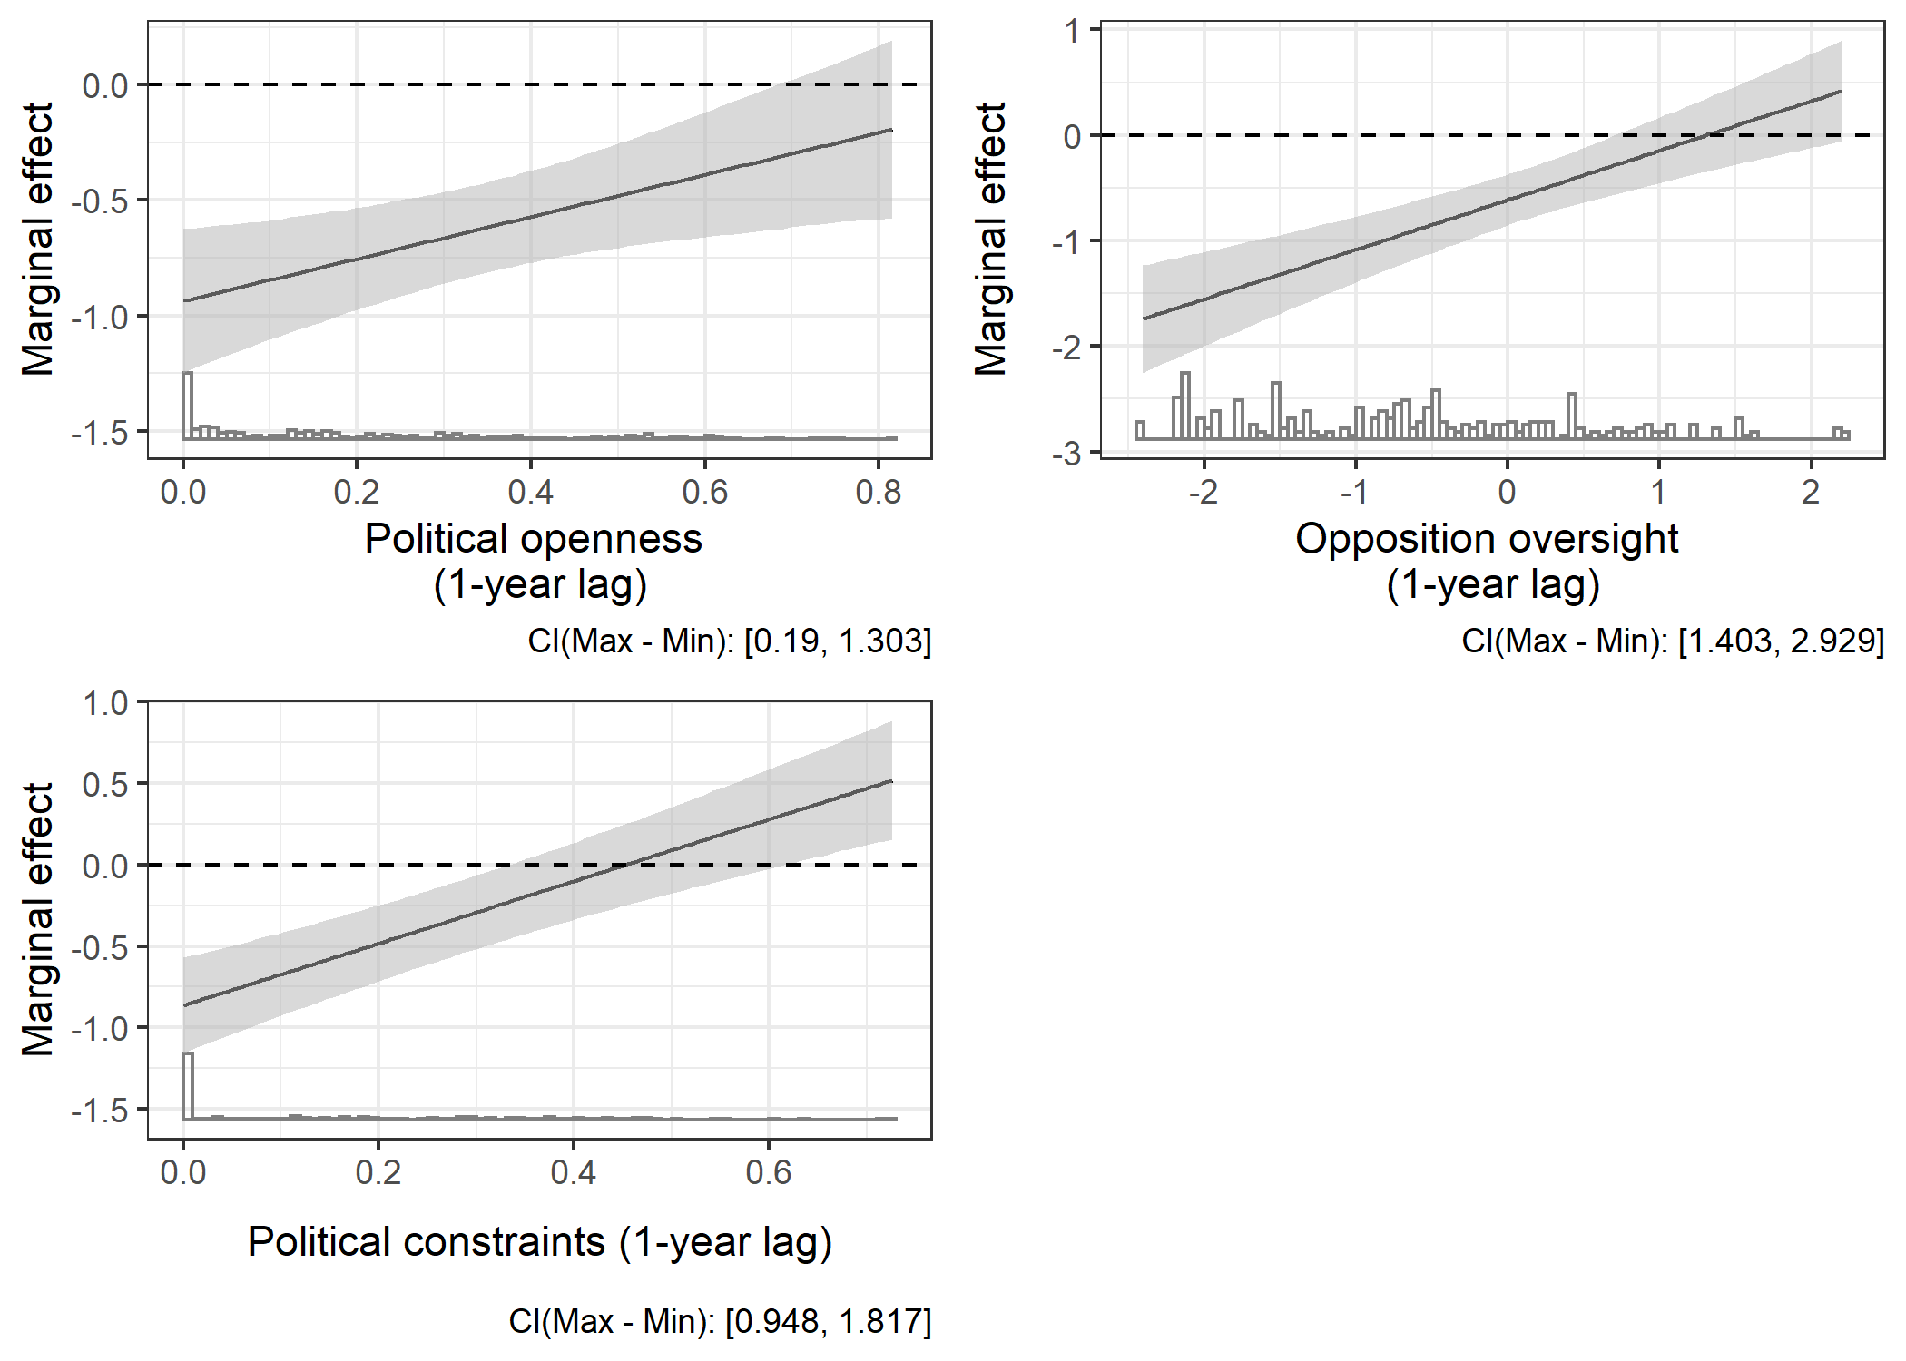

Figure A.9: Marginal effects of a positive judicial reform on intentional voting irregularities. Shaded areas represent 95% confidence intervals

## The post-Cold War effect

One of the foundations of the theory of judicial independence articulated in the main text is that ruling parties in non-democracies derive genuine benefits from independent courts; they will allow those courts to operate independently so long as those benefits outweigh the negative costs of unfavorable court rulings. This yields an additional testable hypothesis in the context of election manipulation. The end of the Cold War changed non-democratic governments’ incentives by increasing the ‘democracy premium’ available in the international system (Hyde, 2011). During the Cold War, democracy credentials often took second consideration behind anti-communism for the United States and other democracy-promoters. Afterward, non-democracies could gain material and symbolic benefits by at least giving the appearance of democratic practice. This shift should, in theory, increase the benefit of allowing courts to rule independently on election-fraud cases for regimes that are relatively secure. We should expect to see a larger reduction in fraud in non-competitive settings in the post-Cold War period than during the Cold War, as a result. The model below includes a dummy variable, *post-Cold War*, which takes on a value of 1 for country-years after 1989. The results in Figure A.10 show the predicted effects.

|  |  |
| --- | --- |
|  | |
|  | *Dependent variable:* |
|  |  |
|  | Intentional voting irregularities (29) |
|  | |
| Political openness | -0.74*** |
|  | (0.20) |
|  |  |
| Positive judicial reform | -0.56*** |
|  | (0.19) |
|  |  |
| Post-Cold War | -0.25 |
|  | (0.15) |
|  |  |
| Executive election | -0.06 |
|  | (0.07) |
|  |  |
| PR system | 0.02 |
|  | (0.08) |
|  |  |
| Mixed electoral system | 0.05 |
|  | (0.10) |
|  |  |
| GDP per capita (log) | -0.17** |
|  | (0.08) |
|  |  |
| Negative judicial reform | -0.07 |
|  | (0.11) |
|  |  |
| Judicial purges | -0.16*** |
|  | (0.05) |
|  |  |
| Court packing | -0.17*** |
|  | (0.06) |
|  |  |
| Political openness : Positive judicial reform | 0.33 |
|  | (0.38) |
|  |  |
| Political openness : post-Cold War | -0.06 |
|  | (0.26) |
|  |  |
| Positive judicial reform : post-Cold War | -0.36 |
|  | (0.26) |
|  |  |
| Political openness : Positive judicial reform : post-Cold War | 1.03** |
|  | (0.47) |
|  |  |
| Country fixed effects | Yes |
| Constant | 3.73*** |
|  | (0.64) |
|  |  |
|  | |
| Observations | 771 |
| R2 | 0.87 |
| Adjusted R2 | 0.84 |
|  | |
| *Note:* | *p<0.1; **p<0.05; ***p<0.01 |

Table A.12: Weighted OLS model of election fraud (entropy balanced weights). All variables 1-year lagged, except *executive election*, *proportional electoral system*, *mixed electoral system*, and *international observers*

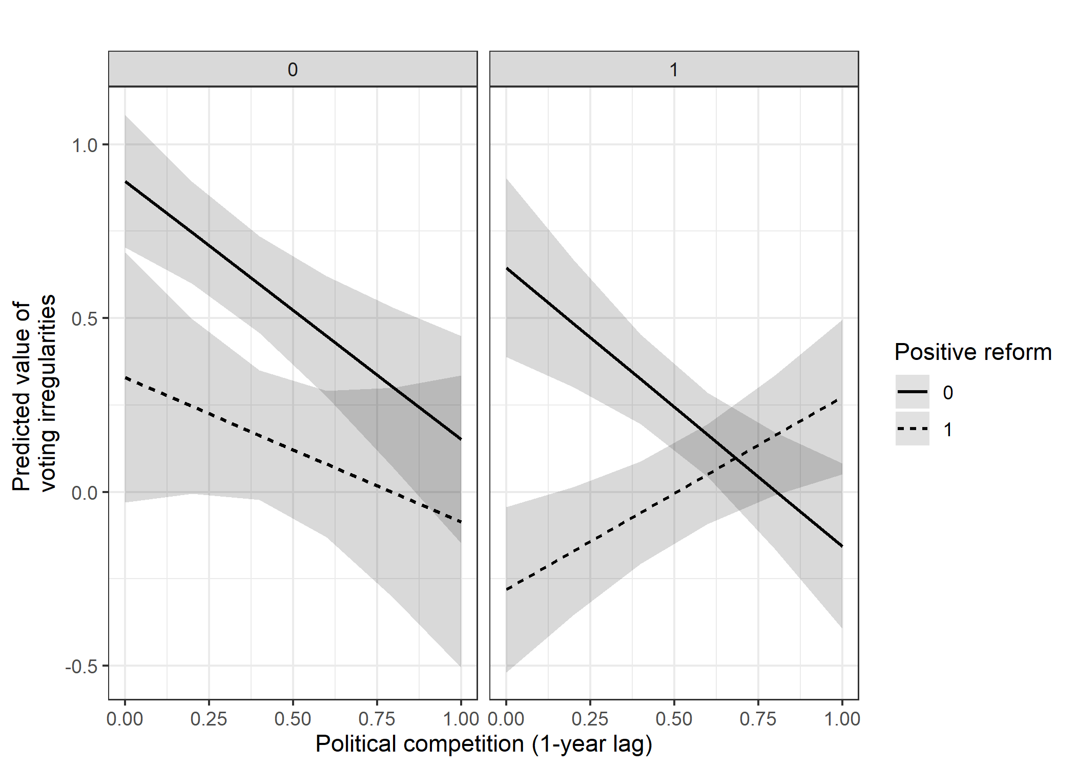

Figure A.10: Marginal effects of a positive judicial reform on intentional voting irregularities. Right-hand panel represents the post-Cold War environment. Shaded areas represent 95% confidence intervals. Control variables held constant at the mean.

## Lagged election manipulation as a selection variable

One possible confounder for this study is the pre-reform ability of the regime to generate election manipulation: it may be that governments that have difficulty motivating election-manipulating agents face little cost from *de jure* reforms and are more likely to implement them as a result. To control for this possibility, the models in Table A.13 include lagged values for *intentional voting irregularities* in the pre-processing selection model. This makes positive judicial reforms conditionally independent of the level of manipulation in the prior election, at the cost of some observations. Figure A.11 shows that the results are substantively similar to those in the main text.

|  |  |  |  |
| --- | --- | --- | --- |
|  | | | |
|  | *Dependent variable:* | | |
|  |  | | |
|  | Intentional voting irregularities | | |
|  | (30) | (31) | (32) |
|  | | | |
| Positive judicial reform | -0.93*** | -0.62*** | -0.61*** |
|  | (0.12) | (0.09) | (0.11) |
|  |  |  |  |
| Political openness | -1.21*** |  |  |
|  | (0.16) |  |  |
|  |  |  |  |
| Opposition oversight |  | -0.41*** |  |
|  |  | (0.04) |  |
|  |  |  |  |
| Political constraints |  |  | -0.40** |
|  |  |  | (0.19) |
|  |  |  |  |
| Executive election | -0.17** | -0.15** | -0.18** |
|  | (0.07) | (0.08) | (0.08) |
|  |  |  |  |
| PR system | -0.14 | -0.15 | -0.15 |
|  | (0.09) | (0.09) | (0.09) |
|  |  |  |  |
| Mixed electoral system | -0.14 | -0.20* | -0.19* |
|  | (0.10) | (0.10) | (0.11) |
|  |  |  |  |
| GDP per capita (log) | -0.23*** | -0.32*** | -0.42*** |
|  | (0.09) | (0.08) | (0.08) |
|  |  |  |  |
| International monitors | -0.22*** | -0.23*** | -0.23*** |
|  | (0.06) | (0.05) | (0.06) |
|  |  |  |  |
| Negative judicial reform | -0.26** | -0.17 | -0.16 |
|  | (0.12) | (0.13) | (0.12) |
|  |  |  |  |
| Judicial purges | -0.20*** | -0.14*** | -0.29*** |
|  | (0.05) | (0.05) | (0.05) |
|  |  |  |  |
| Court packing | -0.14** | -0.06 | -0.15** |
|  | (0.07) | (0.07) | (0.07) |
|  |  |  |  |
| Positive judicial reform : Political openness | 1.16*** |  |  |
|  | (0.22) |  |  |
|  |  |  |  |
| Positive judicial reform : Opposition oversight |  | 0.29*** |  |
|  |  | (0.06) |  |
|  |  |  |  |
| Positive judicial reform : Political constraints |  |  | 0.75*** |
|  |  |  | (0.25) |
|  |  |  |  |
| Country fixed effects | Yes | Yes | Yes |
| Constant | 4.51*** | 5.01*** | 5.54*** |
|  | (0.67) | (0.66) | (0.67) |
|  |  |  |  |
|  | | | |
| Observations | 701 | 663 | 701 |
| R2 | 0.87 | 0.88 | 0.86 |
| Adjusted R2 | 0.84 | 0.86 | 0.83 |
|  | | | |
| *Note:* | *p<0.1; **p<0.05; ***p<0.01 | | |

Table A.13: Weighted OLS model of election fraud (entropy balanced weights). All variables 1-year lagged, except *executive election*, *proportional electoral system*, *mixed electoral system*, and *international observers*

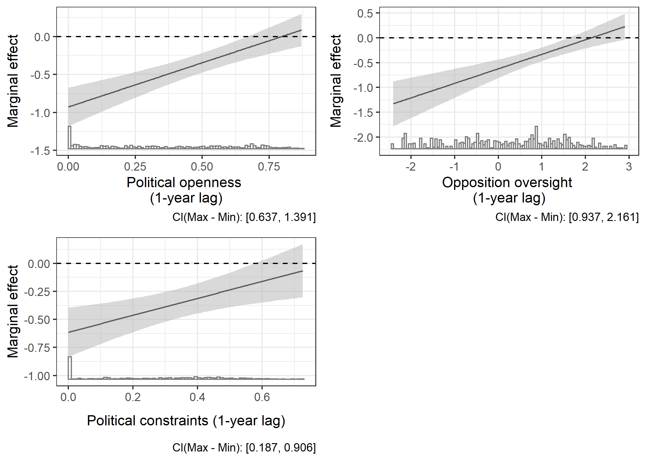

Figure A.11: Marginal effects of a positive judicial reform on intentional voting irregularities. Shaded areas represent 95% confidence intervals

## Government control of the legislature as a selection variable

The following models include the variable *government seat share* in the selection models, to balance treatment and control groups across the size of the government’s faction in the legislature. The variable is constructed from the Database of Political Institutions (Cruz et al., 2017), by dividing the number of pro-government seats by the total number of seats in the legislature. This reduces the sample size, but helps control for the possibility that the government’s relative dominance of the legislature affects both its desire to implement judicial reforms and its ability to generate election manipulation. The results, shown in figure A.12 and Table A.14, are consistent with those of the main models.

|  |  |  |  |
| --- | --- | --- | --- |
|  | | | |
|  | *Dependent variable:* | | |
|  |  | | |
|  | Intentional voting irregularities | | |
|  | (33) | (34) | (35) |
|  | | | |
| Positive judicial reform | -1.07*** | -0.57*** | -0.68*** |
|  | (0.15) | (0.11) | (0.12) |
|  |  |  |  |
| Political openness | -1.30*** |  |  |
|  | (0.21) |  |  |
|  |  |  |  |
| Opposition oversight |  | -0.42*** |  |
|  |  | (0.05) |  |
|  |  |  |  |
| Political constraints |  |  | -0.59*** |
|  |  |  | (0.21) |
|  |  |  |  |
| Executive election | -0.08 | -0.14* | -0.14* |
|  | (0.08) | (0.08) | (0.08) |
|  |  |  |  |
| PR system | -0.16 | -0.31*** | -0.25** |
|  | (0.10) | (0.11) | (0.11) |
|  |  |  |  |
| Mixed electoral system | -0.04 | -0.17 | -0.14 |
|  | (0.11) | (0.12) | (0.11) |
|  |  |  |  |
| GDP per capita (log) | -0.22* | -0.39*** | -0.27** |
|  | (0.11) | (0.13) | (0.12) |
|  |  |  |  |
| International monitors | -0.27*** | -0.30*** | -0.29*** |
|  | (0.06) | (0.06) | (0.06) |
|  |  |  |  |
| Negative judicial reform | 0.02 | 0.04 | 0.02 |
|  | (0.15) | (0.18) | (0.15) |
|  |  |  |  |
| Judicial purges | -0.09 | -0.07 | -0.17*** |
|  | (0.06) | (0.06) | (0.06) |
|  |  |  |  |
| Court packing | -0.11 | -0.04 | -0.19** |
|  | (0.08) | (0.09) | (0.08) |
|  |  |  |  |
| Positive judicial reform:Political openness | 1.81*** |  |  |
|  | (0.25) |  |  |
|  |  |  |  |
| Positive judicial reform:Opposition oversight |  | 0.39*** |  |
|  |  | (0.07) |  |
|  |  |  |  |
| Positive judicial reform:Political constraints |  |  | 1.50*** |
|  |  |  | (0.27) |
|  |  |  |  |
| Country fixed effects | Yes | Yes | Yes |
| Constant | 2.94*** | 3.72*** | 2.64*** |
|  | (0.77) | (0.86) | (0.79) |
|  |  |  |  |
|  | | | |
| Observations | 547 | 503 | 547 |
| R2 | 0.89 | 0.89 | 0.88 |
| Adjusted R2 | 0.87 | 0.86 | 0.86 |
|  | | | |
| *Note:* | *p<0.1; **p<0.05; ***p<0.01 | | |

Table A.14: Weighted OLS model of election fraud (entropy balanced weights). All variables 1-year lagged, except *executive election*, *proportional electoral system*, *mixed electoral system*, and *international observers*

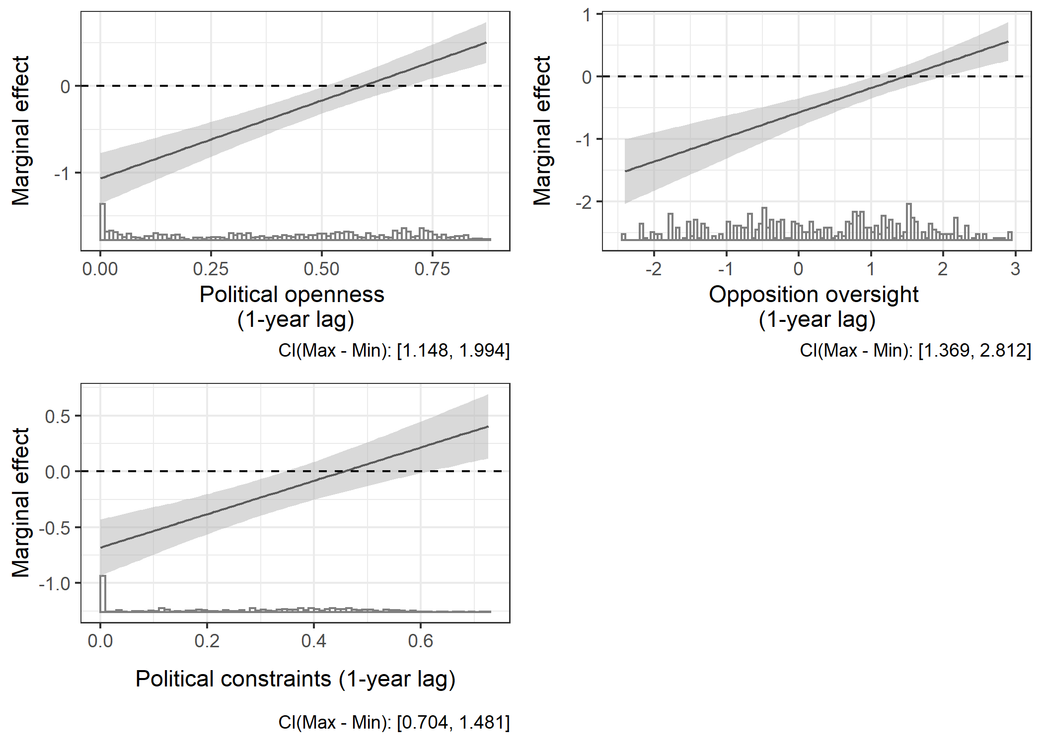

Figure A.12: Marginal effects of a positive judicial reform on intentional voting irregularities. Shaded areas represent 95% confidence intervals

## Judicial independence and access to the courts

The theoretical mechanism proposed in the main text—that positive judicial reforms create incentives for more vigorous legal mobilization by regime opponents, raising the costs of electoral manipulation for ruling parties—rests in part on the assumption that citizens have access to the courts. In part, that is, because complaints about electoral malfeasance may not be brought to court only by citizens or political parties, but also by prosecutors. Nonetheless, high costs of bringing cases to court, procedural issues like questions of standing, or rules that require electoral complaints to be heard in specialized courts (see above) may inhibit access to the courts, making it harder for affected parties to bring cases and insulating the ruling party and its agents from costs associated with manipulated elections. The main explanatory variable in this study, *positive judicial reforms*, encompasses reforms that increase judicial independence as well as judicial access, meaning that it alone does not distinguish between these two related mechanisms

While I am unaware of detailed cross-national data on judicial access for cases related to elections, the Comparative Constitutions Project offers a rough proxy that can be used to better isolate the independent effect of judicial independence (controlling for access). Specifically, CCP data records which entities are explicitly granted the right to challenge laws in court, and whether or not there is a constitutional *amparo* right—the right of any citizens to allege in court that their political or civil rights have been violated. Again, these are rough proxies; a broad right to challenge laws does not necessarily imply that allegations of electoral misconduct can be easily heard. For this reason, I do not include these variables in the main models. Still, given the unavailability of more fine-grained data, it is plausible that judicial openness of civil legal questions will be associated with judicial openness generally.

To construct this control variable, I add the values of three binary variables from the CCP dataset; these variable indicate whether the constitution formally grants the right to challenge laws to citizens or to lawyers, and whether there is a constitutional *amparo* provision. The combined variable, *citizen access*, thus ranges from zero to three. Most country-year observations in the dataset score zero on this measure, but approximately one-third of observations take a positive value. I include this variable as a control in models otherwise identical to those in the main text. As Table A15 and the associated figures show, there is no substantive difference between the main models and those that include a proxy for judicial access; this helps improve confidence in the argument that judicial independence has an effect on electoral manipulation independent of access.

|  |  |  |  |
| --- | --- | --- | --- |
|  | | | |
|  | *Dependent variable:* | | |
|  |  | | |
|  | Intentional voting irregularities | | |
|  | (1) | (2) | (3) |
|  | | | |
| Positive judicial reform | -0.646*** | -0.391*** | -0.487*** |
|  | (0.141) | (0.104) | (0.117) |
|  |  |  |  |
| Political openness | -0.626*** |  |  |
|  | (0.211) |  |  |
|  |  |  |  |
| Opposition oversight |  | -0.312*** |  |
|  |  | (0.043) |  |
|  |  |  |  |
| Political constraints |  |  | -0.400* |
|  |  |  | (0.225) |
|  |  |  |  |
| Executive election | 0.011 | 0.044 | 0.001 |
|  | (0.077) | (0.075) | (0.078) |
|  |  |  |  |
| Proportional electoral system | 0.036 | 0.097 | 0.025 |
|  | (0.099) | (0.096) | (0.100) |
|  |  |  |  |
| Mixed electoral system | -0.086 | -0.078 | -0.119 |
|  | (0.108) | (0.104) | (0.110) |
|  |  |  |  |
| Log GDP per capita (lagged) | -0.654*** | -0.679*** | -0.801*** |
|  | (0.119) | (0.102) | (0.104) |
|  |  |  |  |
| International monitors | -0.053 | -0.067 | -0.027 |
|  | (0.073) | (0.070) | (0.074) |
|  |  |  |  |
| Negative reform | -0.332** | -0.340** | -0.341** |
|  | (0.141) | (0.141) | (0.146) |
|  |  |  |  |
| Judicial purges | -0.247*** | -0.184*** | -0.309*** |
|  | (0.064) | (0.060) | (0.061) |
|  |  |  |  |
| Court packing | -0.109 | -0.032 | -0.072 |
|  | (0.070) | (0.074) | (0.070) |
|  |  |  |  |
| Citizen access | 0.116 | 0.083 | 0.218*** |
|  | (0.083) | (0.086) | (0.082) |
|  |  |  |  |
| Positive reform : Political openness | 0.868*** |  |  |
|  | (0.253) |  |  |
|  |  |  |  |
| Positive reform: Opposition oversight |  | 0.153** |  |
|  |  | (0.060) |  |
|  |  |  |  |
| Positive reform : Political constraints |  |  | 0.778*** |
|  |  |  | (0.267) |
|  |  |  |  |
| Constant | 6.994*** | 7.333*** | 7.899*** |
|  | (0.885) | (0.805) | (0.843) |
|  |  |  |  |
|  | | | |
| Country fixed effects | Yes | Yes | Yes |
| Observations | 520 | 492 | 520 |
| R2 | 0.884 | 0.905 | 0.882 |
| Adjusted R2 | 0.854 | 0.878 | 0.851 |
|  | | | |
| *Note:* | *p<0.1; **p<0.05; ***p<0.01 | | |

Table A.15: Weighted OLS model of election fraud (entropy balanced weights). All variables 1-year lagged, except *executive election*, *proportional electoral system*, *mixed electoral system*, and *international observers*

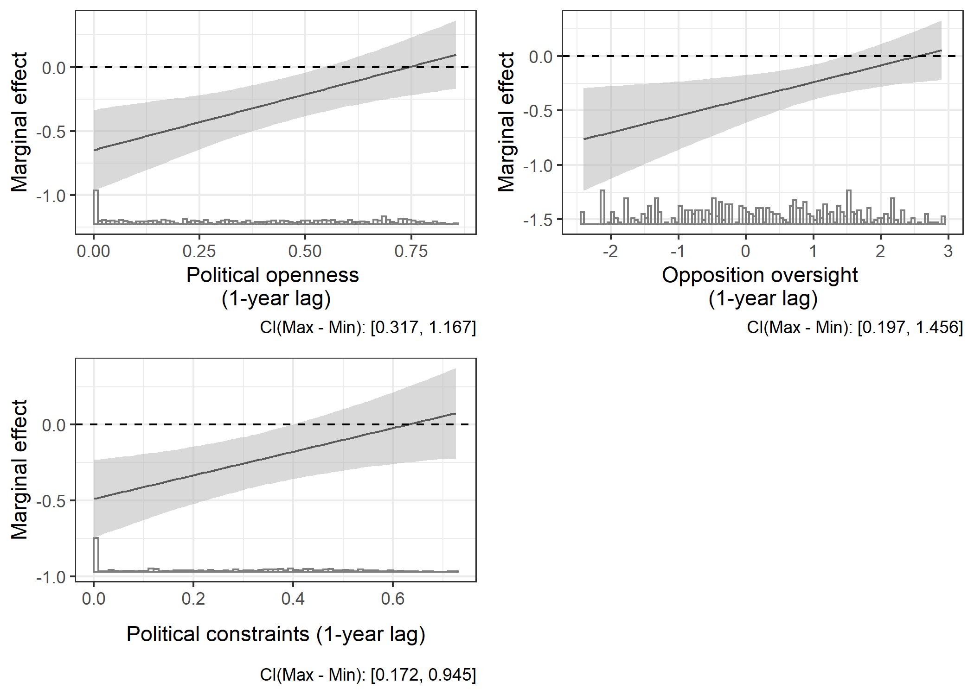

Figure A.13: Marginal effects of a positive judicial reform on intentional voting irregularities. Shaded areas represent 95% confidence intervals

## Bibliography

Boix, C., Miller, M., & Rosato, S. (2013). A Complete Data Set of Political Regimes, 1800–2007. *Comparative Political Studies*, *46*(12), 1523–1554. https://doi.org/10.1177/0010414012463905

Cheibub, J. A., Gandhi, J., & Vreeland, J. R. (2010). Democracy and dictatorship revisited. In *Public Choice* (Vol. 143, Issue 1). https://doi.org/10.1007/s11127-009-9491-2

Coppedge, Michael, Gerring, John, Lindberg, Staffan I., Skaaning, Svend-Erik, Teorell, Jan, Altman, David, Andersson, Frida, Bernhard, Michael, Fish, Steven M., Glynn, Adam, Hicken, Allen, Knutsen, Carl Henrik, Marquardt, Kyle L., McMann, Kelly, Mechkova, Valeriya, Paxton, Pamela, Pemstein, Daniel, Saxer, Laura, Seim, Brigitte, … Staton, Jeffrey. (2017). *V-Dem Codebook v7*. Varieties of Democracy (V-Dem) Project.

Cruz, C., Keefer, P., & Scartascini, C. (2017). *Database of Political Institutions 2017 (DPI2017)*. https://mydata.iadb.org/Reform-Modernization-of-the-State/%0ADatabase-of-Political-Institutions-2017/938i-s2bw

Hainmueller, J., Mummolo, J., & Xu, Y. (2019). How Much Should We Trust Estimates from Multiplicative Interaction Models? Simple Tools to Improve Empirical Practice. *Political Analysis*, *27*(2), 163–192. https://doi.org/10.1017/pan.2018.46

Hale, H. E. (2014). *Patronal Politics: Eurasian Regime Dynamics in Comparative Perspective*. Cambridge University Press.

Hyde, S. D. (2011). Catch Us If You Can: Election Monitoring and International Norm Diffusion. *American Journal of Political Science*, *55*(2), 356–369. https://doi.org/10.1111/j.1540-5907.2011.00508.x

Hyde, S. D., & Marinov, N. (2012). Which elections can be lost? *Political Analysis*, *20*(2), 191–210. https://doi.org/10.1093/pan/mpr040

Imai, K., & Ratkovic, M. (2014). Covariate balancing propensity score. *Journal of the Royal Statistical Society. Series B: Statistical Methodology*, *76*(1), 243–263. https://doi.org/10.1111/rssb.12027

Magalhães, P. C. (1999). The Politics of Judicial Reform in Eastern Europe. *Comparative Politics*, *32*(1), 43–62.

Melton, J., & Ginsburg, T. (2014). Does De Jure Judicial Independence Really Matter? *Journal of Law and Courts*, *2*(2), 187–217. https://doi.org/10.1086/676999

Rundlett, A., & Svolik, M. W. (2016). Deliver the Vote! Micromotives and Macrobehavior in Electoral Fraud. *American Political Science Review*, *110*(01), 180–197. https://doi.org/10.1017/S0003055415000635

1. See Federal Constitutional Law “On the Judicial System of the Russian Federation.”
2. This variable indicates if there were riots or protests after the election that were backed by allegations of fraud.
3. Categories include closed autocracy, electoral autocracy, electoral democracy, and liberal democracy.